DevSecOps PIPELINE PROJECT
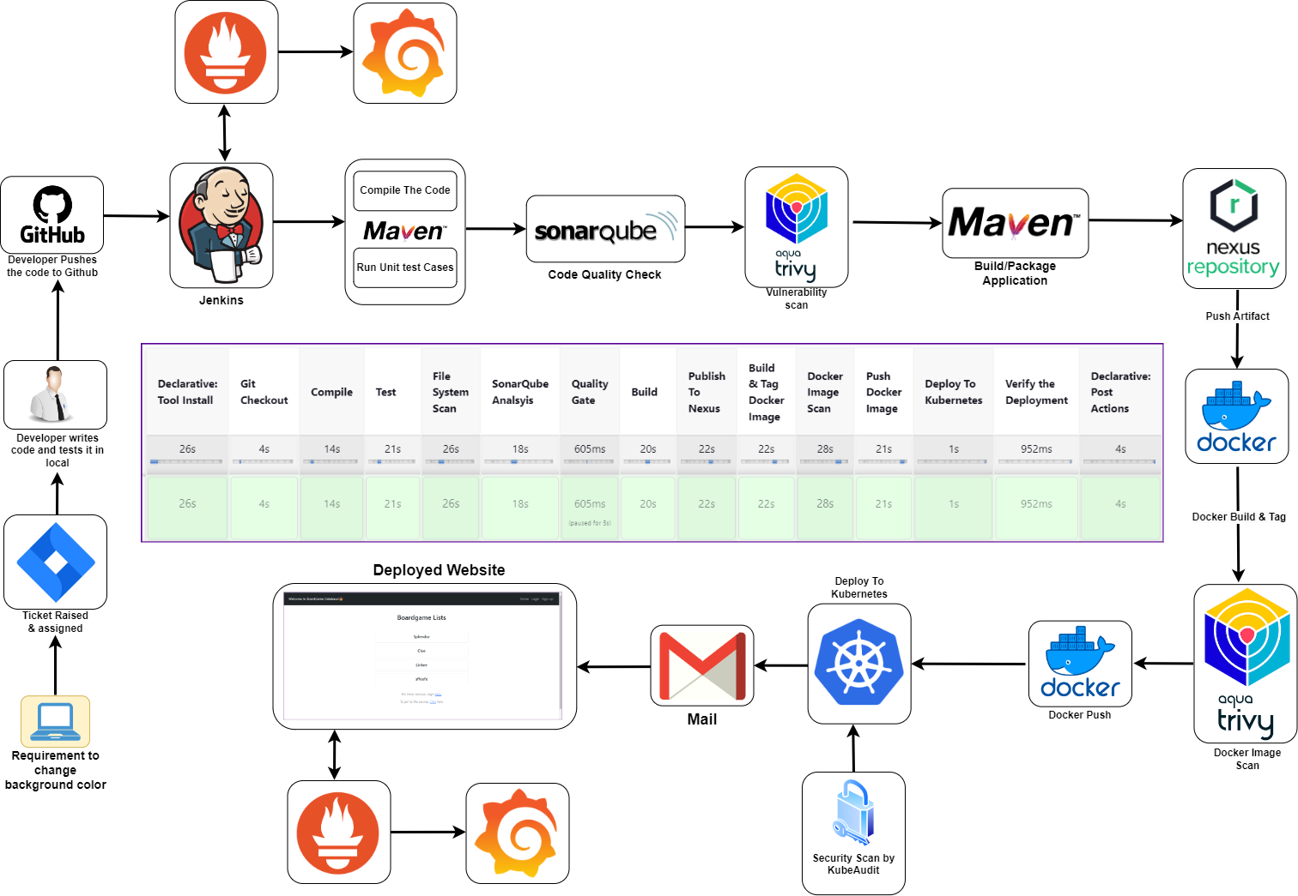
PHASE-1 | Setup Infra
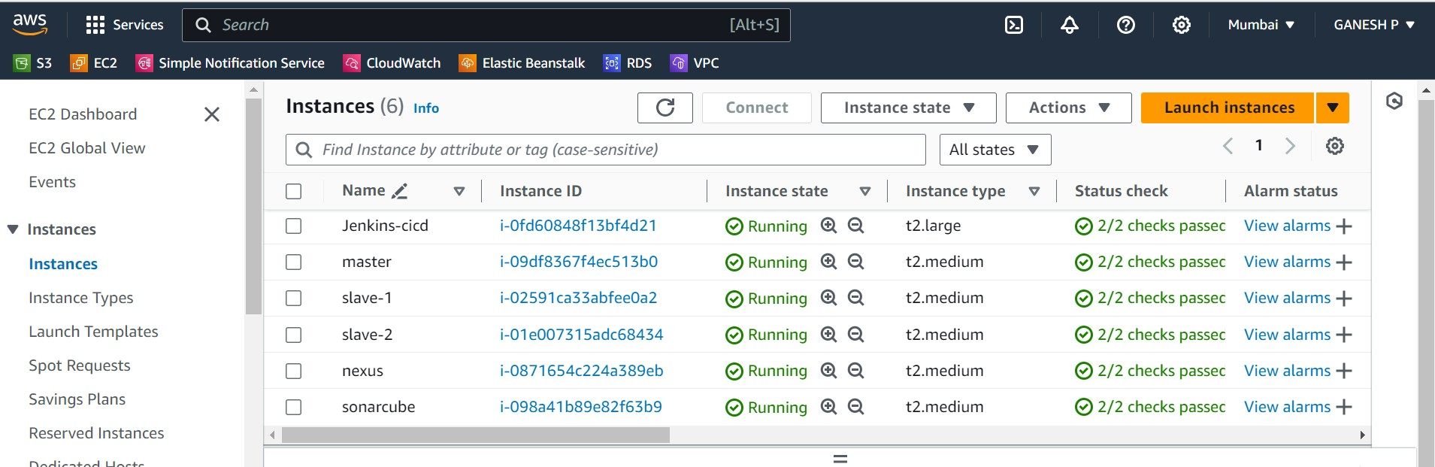
To create an Ubuntu EC2 instance in AWS, follow these steps:
- Sign in to the AWS Management Console:
o Go to the AWS Management Console at https://aws.amazon.com/console/. o Sign in with your AWS account credentials.
- Navigate to EC2:
o Once logged in, navigate to the EC2 dashboard by typing "EC2" in the search bar at the top or by selecting "Services" and then "EC2" under the "Compute" section.
- Launch Instance:
o Click on the "Instances" link in the EC2 dashboard sidebar. o Click the "Launch Instance" button.
- Choose an Amazon Machine Image (AMI):
    - In the "Step 1: Choose an Amazon Machine Image (AMI)" section, select "Ubuntu" from the list of available AMIs.
    - Choose the Ubuntu version you want to use. For example, "Ubuntu Server 24.04 LTS". o Click "Select".
- Choose an Instance Type:
    - In the "Step 2: Choose an Instance Type" section, select the instance type that fits your requirements. The default option (usually a t2.micro instance) is suitable for testing and small workloads.
    - Click "Next: Configure Instance Details".
- Configure Instance Details:
  - Optionally, configure instance details such as network settings, subnets, IAM role, etc. You can leave these settings as default for now.
  - Click "Next: Add Storage".
- Add Storage:
  - Specify the size of the root volume (default is usually fine for testing purposes). o Click "Next: Add Tags".
- Add Tags:
  - Optionally, add tags to your instance for better organization and management. o Click "Next: Configure Security Group".
- Configure Security Group:
  - In the "Step 6: Configure Security Group" section, configure the security group to allow SSH access (port 22) from your IP address.
  - You may also want to allow other ports based on your requirements (e.g., HTTP, HTTPS) as in this pic
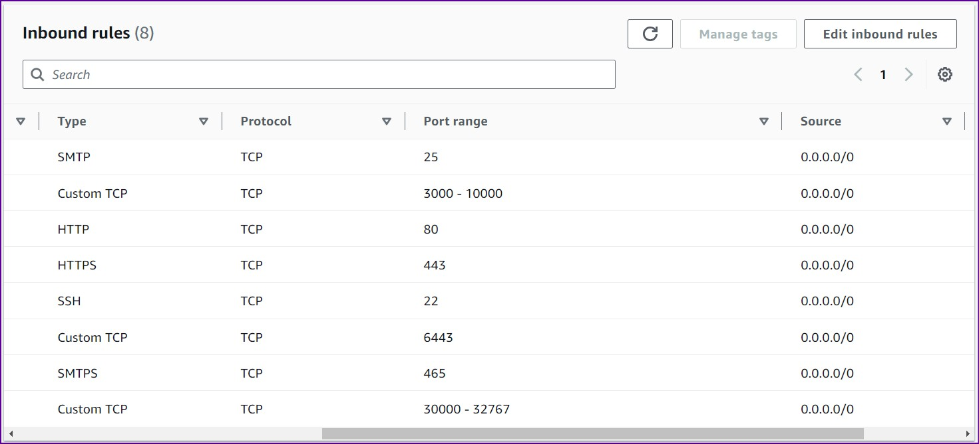
  - Click "Review and Launch".
- Review and Launch: o Review the configuration of your instance. o Click "Launch".
- Select Key Pair:
      - In the pop-up window, select an existing key pair or create a new one. o Check the acknowledgment box.
      - Click "Launch Instances".
- Access Your Instance:
o Use Mobaxterm

Setup K8-Cluster using kubeadm [K8 Version-->1.28.1]
1. Update System Packages [On Master & Worker Node]
sudo apt-get update

2. Install Docker[On Master & Worker Node]
sudo apt install docker.io -y sudo chmod 666 /var/run/docker.sock

3. Install Required Dependencies for Kubernetes[On Master & Worker Node]
sudo apt-get install -y apt-transport-https ca-certificates curl gnupg sudo mkdir -p -m 755 /etc/apt/keyrings

4. Add Kubernetes Repository and GPG Key[On Master & Worker Node]
curl -fsSL https://pkgs.k8s.io/core:/stable:/v1.28/deb/Release.key | sudo gpg -dearmor -o /etc/apt/keyrings/kubernetes-apt-keyring.gpg echo 'deb [signed-by=/etc/apt/keyrings/kubernetes-apt-keyring.gpg] https://pkgs.k8s.io/core:/stable:/v1.28/deb/ /' | sudo tee /etc/apt/sources.list.d/kubernetes.list
5. Update Package List[On Master & Worker Node]
sudo apt update

6. Install Kubernetes Components[On Master & Worker Node]
sudo apt install -y kubeadm=1.28.1-1.1 kubelet=1.28.1-1.1 kubectl=1.28.1-1.1
kubeadm - Going to setup a Kubernetes cluster
kubelet - Responsible for creating pods which we are going to deploy applications kubectl - will work as cli to interact with the k8s cluster 7. Initialize Kubernetes Master Node [On MasterNode]
sudo kubeadm init --pod-network-cidr=10.244.0.0/16
After run the above command then our vm will acts as master node and it will generate token to connect this with slave node -copy the token and run the command in slave machines 1 & 2

8. Configure Kubernetes Cluster [On MasterNode]
mkdir -p $HOME/.kube
sudo cp -i /etc/kubernetes/admin.conf $HOME/.kube/config sudo chown $(id -u):$(id -g) $HOME/.kube/config
9. Deploy Networking Solution (Calico) [On MasterNode]
kubectl apply -f https://docs.projectcalico.org/v3.20/manifests/calico.yaml

10. Deploy Ingress Controller (NGINX) [On MasterNode]
kubectl apply -f https://raw.githubusercontent.com/kubernetes/ingressnginx/controller-v0.49.0/deploy/static/provider/baremetal/deploy.yaml
11. We'll Scan Kubernetes Cluster For Any Kind Of Issues For That We Have Multiple Tools Like
Trivy Also We Have But Trivy May Not Work Always So For That Reason We Are Just Going To Go
With Cube Audit It Also A Tool That Can Be Used For Scanning
->https://github.com/shopify/kubeaudit/releases (Go To The Web Site Copy The Linux_amd_64
Link)
->Paste It Using wget Command
->Now Untar The File Using tar -xvf File Name
->sudo mv kubeaudit /usr/local/bin/
->kubeaudit all

Installing Jenkins on Ubuntu
#!/bin/bash
# Install OpenJDK 17 JRE Headless sudo apt install openjdk-17-jre-headless -y
# Download Jenkins GPG key
sudo wget -O /usr/share/keyrings/jenkins-keyring.asc \ https://pkg.jenkins.io/debian-stable/jenkins.io-2023.key
# Add Jenkins repository to package manager sources echo deb [signed-by=/usr/share/keyrings/jenkins-keyring.asc] \
https://pkg.jenkins.io/debian-stable binary/ | sudo tee \
/etc/apt/sources.list.d/jenkins.list > /dev/null
# Update package manager repositories sudo apt-get update
# Install Jenkins sudo apt-get install jenkins -y
Save this script in a file, for example, install_jenkins.sh, and make it executable using: chmod +x install_jenkins.sh Then, you can run the script using:
./install_jenkins.sh
This script will automate the installation process of OpenJDK 17 JRE Headless and
Jenkins.
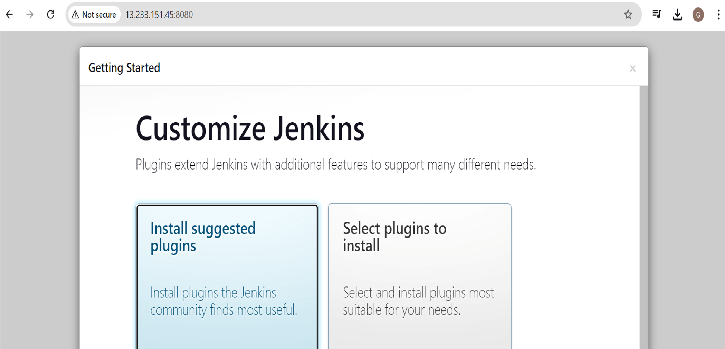
Now we can able to access Jenkins :using the public ip address http://IP:8080
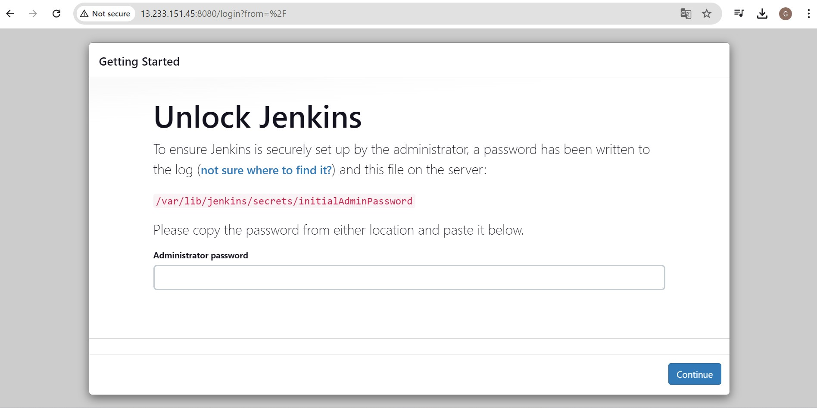
Use the below command on your jenkins machine
sudo cat /var/lib/jenkins/secrets/initialAdminPassword
Get password it will be like this —> a771e06575b54f91bc56a42ccdbb2f76
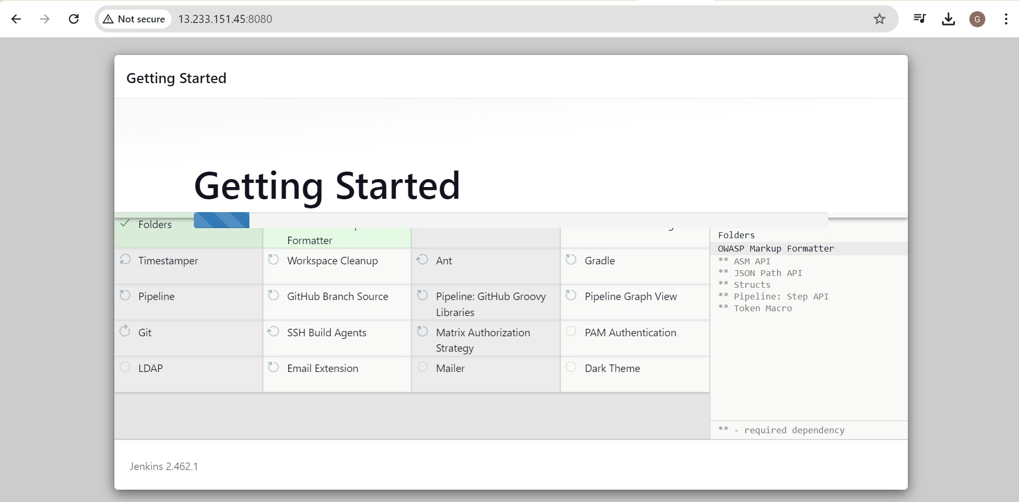
Install the suggested packages and create user with your name and password
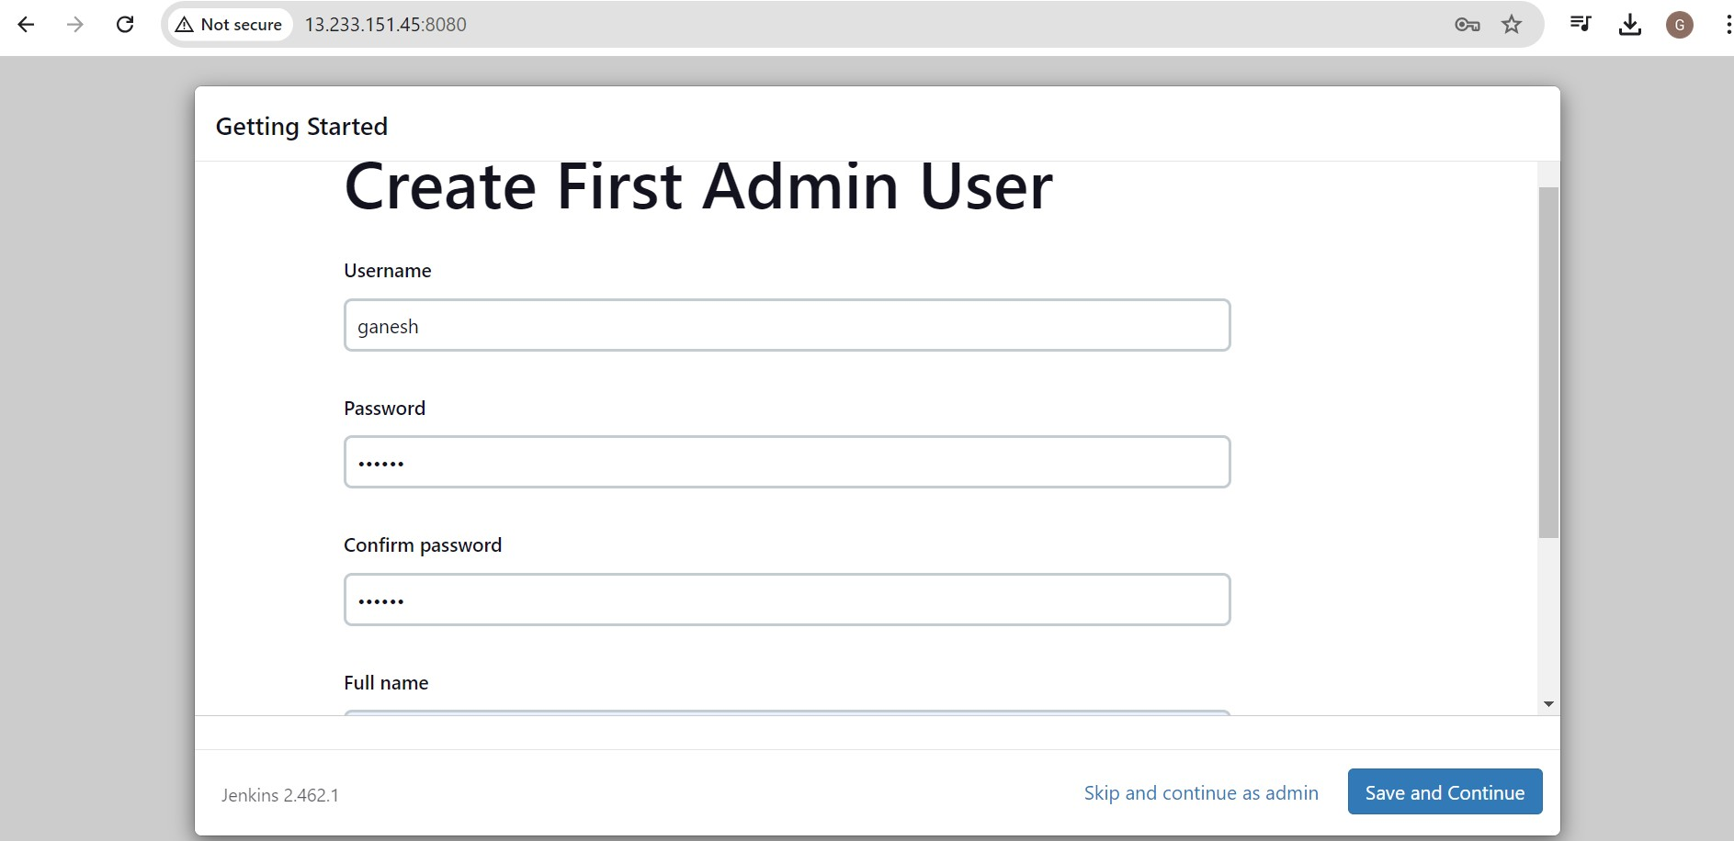

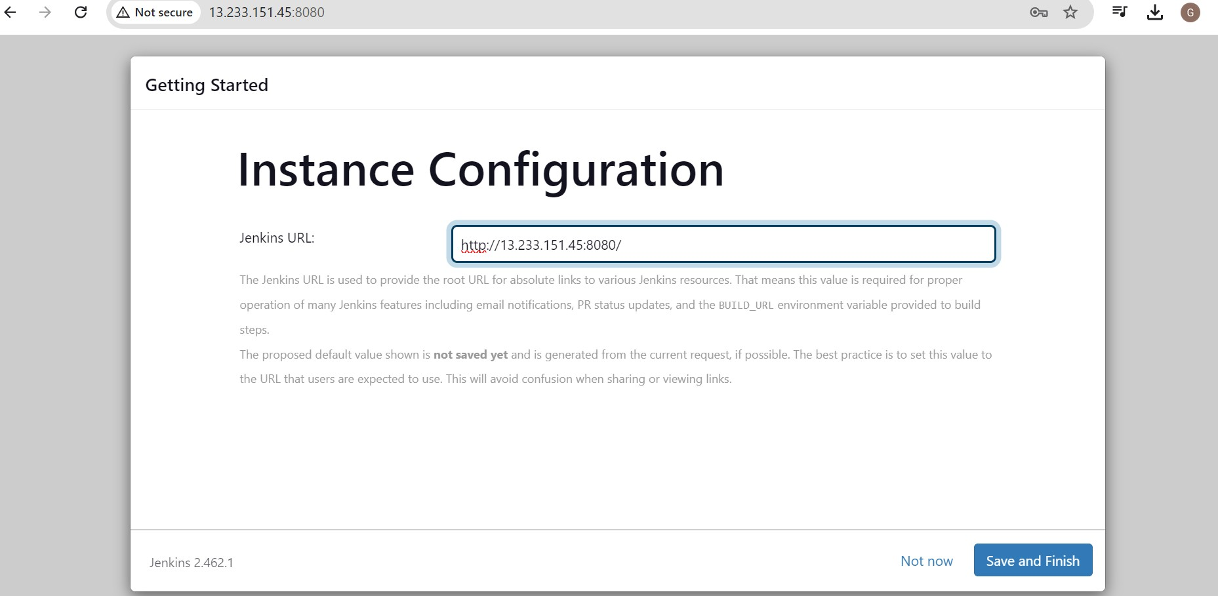
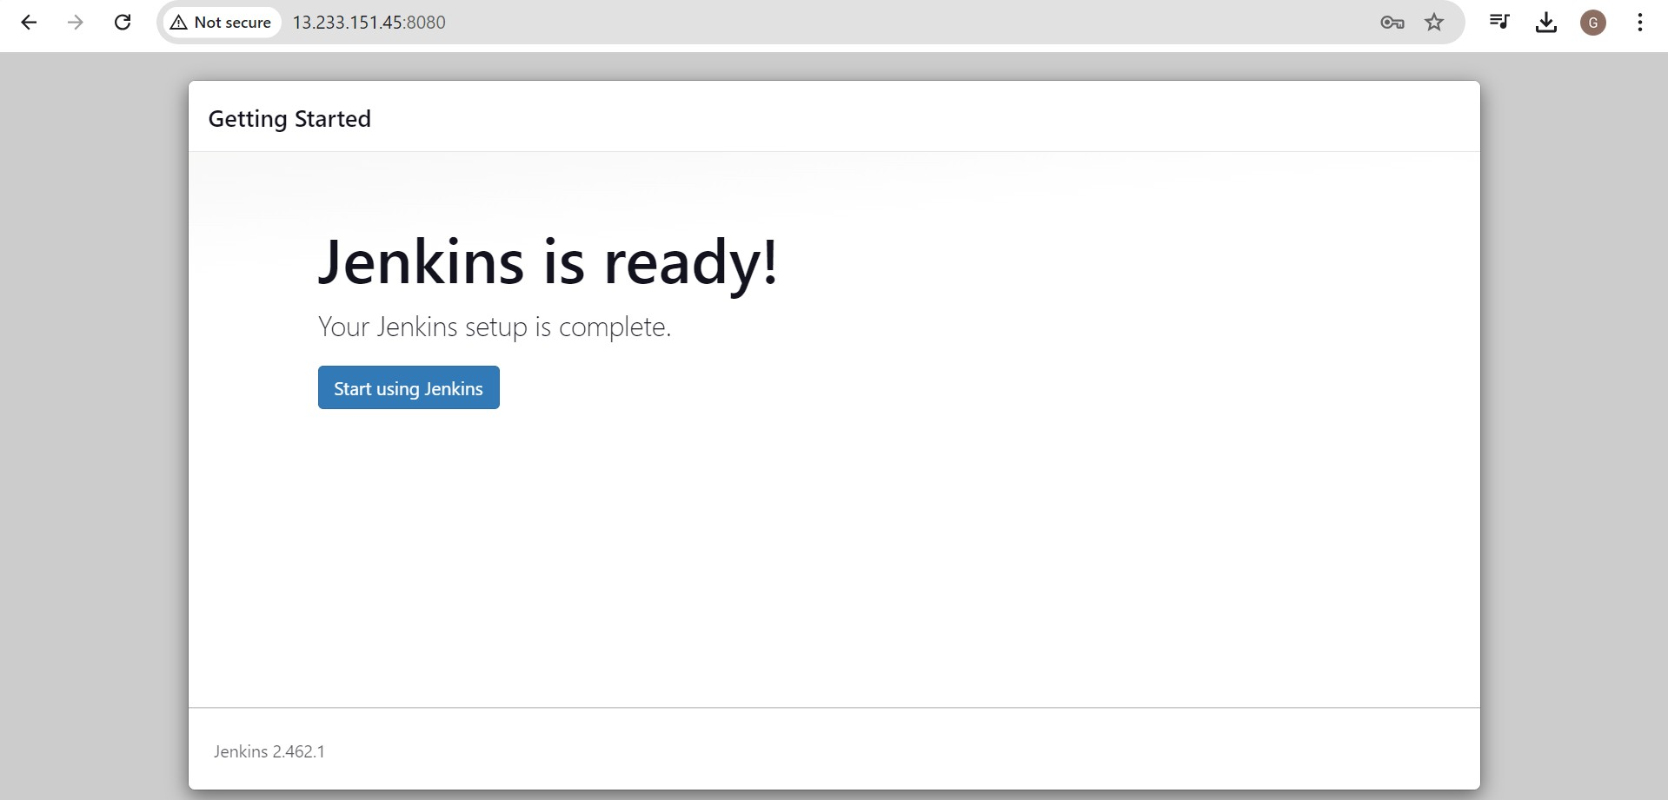

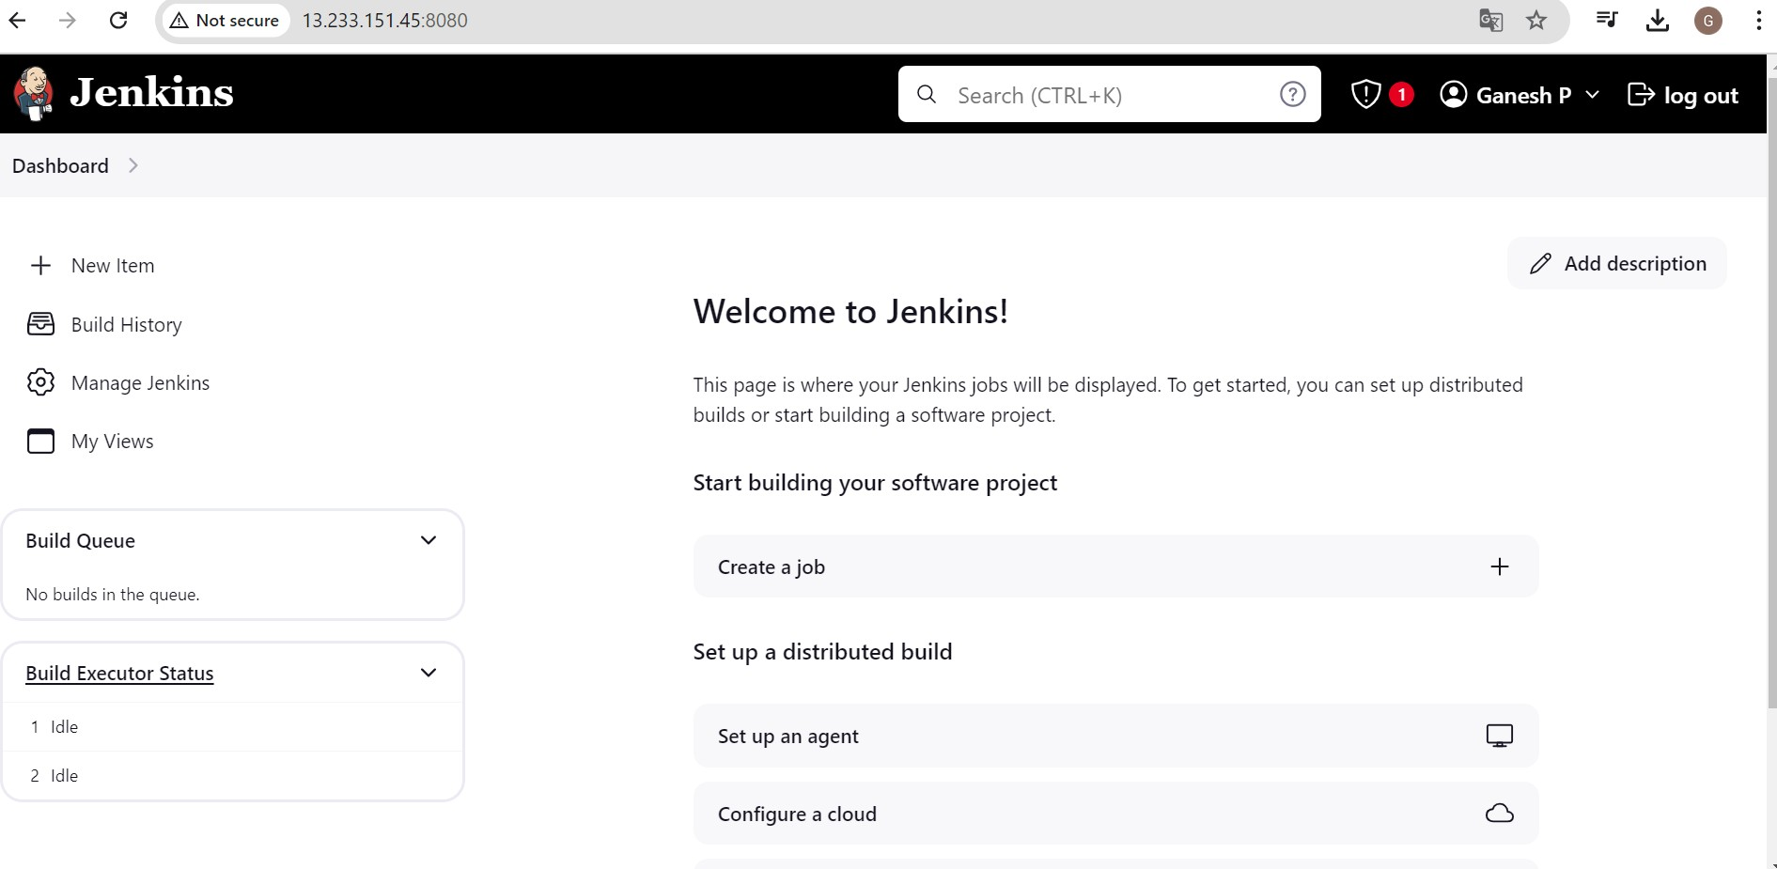
Install docker and trivy on Jenkins machine for future use
#!/bin/bash
# Update package manager repositories sudo apt-get update
# Install necessary dependencies sudo apt-get install -y ca-certificates curl
# Create directory for Docker GPG key sudo install -m 0755 -d /etc/apt/keyrings
# Download Docker's GPG key
sudo curl -fsSL https://download.docker.com/linux/ubuntu/gpg -o
/etc/apt/keyrings/docker.asc
# Ensure proper permissions for the key sudo chmod a+r /etc/apt/keyrings/docker.asc
# Add Docker repository to Apt sources echo "deb [arch=$(dpkg --print-architecture) signed-
by=/etc/apt/keyrings/docker.asc] https://download.docker.com/linux/ubuntu \
$(. /etc/os-release && echo "$VERSION_CODENAME") stable" | \ sudo tee /etc/apt/sources.list.d/docker.list > /dev/null
# Update package manager repositories sudo apt-get update
sudo apt-get install -y docker-ce docker-ce-cli containerd.io docker-buildx-plugin docker-compose-plugin
Save this script in a file, for example, install_docker.sh, and make it executable using:
chmod +x install_docker.sh
Then, you can run the script using:
./install_docker.sh
Trivy Installation Steps:
#!/bin/bash sudo apt-get install wget apt-transport-https gnupg lsb-release
wget -qO - https://aquasecurity.github.io/trivy-repo/deb/public.key | gpg --dearmor | sudo tee
/usr/share/keyrings/trivy.gpg > /dev/null
echo "deb [signed-by=/usr/share/keyrings/trivy.gpg]
https://aquasecurity.github.io/trivy-repo/deb $(lsb_release -sc) main" | sudo tee -a /etc/apt/sources.list.d/trivy.list
sudo apt-get update sudo apt-get install trivy -y
After creating the script change the permission to executable file chmod +x trivy.sh
ls
./trivy.sh trivy –version

SetUp Nexus
#!/bin/bash
# Update package manager repositories sudo apt-get update
# Install necessary dependencies sudo apt-get install -y ca-certificates curl
# Create directory for Docker GPG key sudo install -m 0755 -d /etc/apt/keyrings
# Download Docker's GPG key
sudo curl -fsSL https://download.docker.com/linux/ubuntu/gpg -o
/etc/apt/keyrings/docker.asc
# Ensure proper permissions for the key sudo chmod a+r /etc/apt/keyrings/docker.asc
# Add Docker repository to Apt sources
echo "deb [arch=$(dpkg --print-architecture) signed-
by=/etc/apt/keyrings/docker.asc] https://download.docker.com/linux/ubuntu \
$(. /etc/os-release && echo "$VERSION_CODENAME") stable" | \ sudo tee /etc/apt/sources.list.d/docker.list > /dev/null
# Update package manager repositories sudo apt-get update
sudo apt-get install -y docker-ce docker-ce-cli containerd.io docker-buildx-plugin docker-compose-plugin
Save this script in a file, for example, install_docker.sh, and make it executable using:
chmod +x install_docker.sh Then, you can run the script using:
./install_docker.sh

Create Nexus using docker container
To create a Docker container running Nexus 3 and exposing it on port 8081, you can use the following command: docker run -d --name nexus -p 8081:8081 sonatype/nexus3:latest This command does the following:
- -d: Detaches the container and runs it in the background.
- --name nexus: Specifies the name of the container as "nexus".
- -p 8081:8081: Maps port 8081 on the host to port 8081 on the container, allowing access to Nexus through port 8081.
- sonatype/nexus3:latest: Specifies the Docker image to use for the container, in this case, the latest version of Nexus 3 from the Sonatype repository.
After running this command, Nexus will be accessible on your host machine at http://IP:8081.
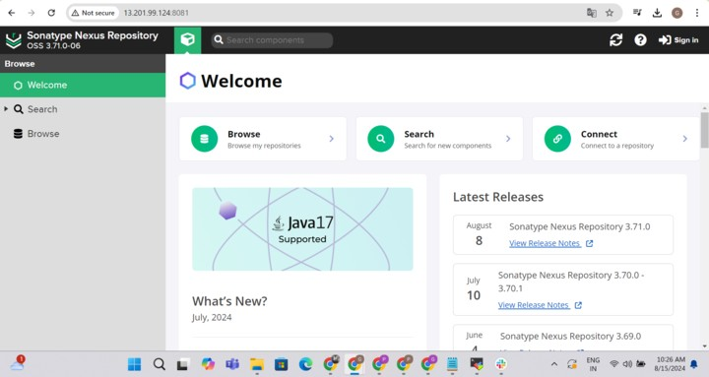
Get Nexus initial password
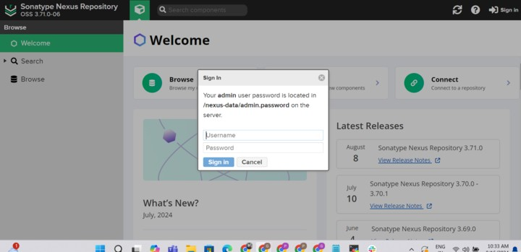
Your provided commands are correct for accessing the Nexus password stored in the container. Here's a breakdown of the steps:
- Get Container ID: You need to find out the ID of the Nexus container. You can do this by running: docker ps
This command lists all running containers along with their IDs, among other information.
- Access Container's Bash Shell: Once you have the container ID, you can execute the docker exec command to access the container's bash shell: docker exec -it <container_ID> /bin/bash
Replace <container_ID> with the actual ID of the Nexus container.
- Navigate to Nexus Directory: Inside the container's bash shell, navigate to the directory where Nexus stores its configuration: cd sonatype-work/nexus3
- View Admin Password: Finally, you can view the admin password by displaying the contents of the admin.password file:
cat admin.password
- Exit the Container Shell: Once you have retrieved the password, you can exit the container's bash shell: exit
This process allows you to access the Nexus admin password stored within the container. Make sure to keep this password secure, as it grants administrative access to your Nexus instance.

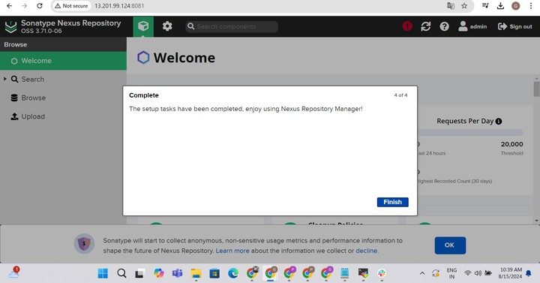

SetUp SonarQube
#!/bin/bash
# Update package manager repositories sudo apt-get update
# Install necessary dependencies sudo apt-get install -y ca-certificates curl
# Create directory for Docker GPG key sudo install -m 0755 -d /etc/apt/keyrings
# Download Docker's GPG key
sudo curl -fsSL https://download.docker.com/linux/ubuntu/gpg -o
/etc/apt/keyrings/docker.asc
# Ensure proper permissions for the key sudo chmod a+r /etc/apt/keyrings/docker.asc
# Add Docker repository to Apt sources echo "deb [arch=$(dpkg --print-architecture) signed-
by=/etc/apt/keyrings/docker.asc] https://download.docker.com/linux/ubuntu \
$(. /etc/os-release && echo "$VERSION_CODENAME") stable" | \ sudo tee /etc/apt/sources.list.d/docker.list > /dev/null
# Update package manager repositories sudo apt-get update
sudo apt-get install -y docker-ce docker-ce-cli containerd.io docker-buildx-plugin docker-compose-plugin
Save this script in a file, for example, install_docker.sh, and make it executable using: chmod +x install_docker.sh Then, you can run the script using:
./install_docker.sh

Create Sonarqube Docker container
To run SonarQube in a Docker container with the provided command, you can follow these steps:
- Open your terminal or command prompt.
- Run the following command: docker run -d --name sonar -p 9000:9000 sonarqube:lts-community
This command will download the sonarqube:lts-community Docker image from Docker
Hub if it's not already available locally. Then, it will create a container named "sonar" from this image, running it in detached mode (-d flag) and mapping port 9000 on the host machine to port 9000 in the container (-p 9000:9000 flag).
- Access SonarQube by opening a web browser and navigating to http://VmIP:9000.
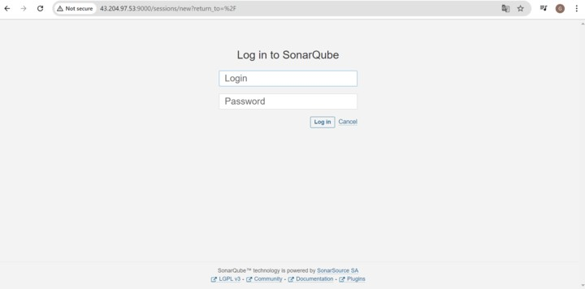
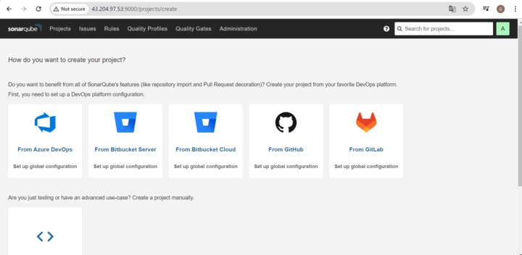
This will start the SonarQube server, and you should be able to access it using the provided URL. If you're running Docker on a remote server or a different port, replace localhost with the appropriate hostname or IP address and adjust the port accordingly.

PHASE-2 | Private Git Setup
Steps to create a private Git repository, generate a personal access token, connect to the repository, and push code to it:
- Create a Private Git Repository:
  - Go to your preferred Git hosting platform (e.g., GitHub, GitLab, Bitbucket).
  - Log in to your account or sign up if you don't have one. o Create a new repository and set it as private.
- Generate a Personal Access Token:
  - Navigate to your account settings or profile settings.
  - Look for the "Developer settings" or "Personal access tokens" section.
  - Generate a new token, providing it with the necessary permissions (e.g., repo access).
- Clone the Repository Locally:
  - Open Git Bash or your terminal.
  - Navigate to the directory where you want to clone the repository. o Use the git clone command followed by the repository's URL. For example:
git clone <repository_URL>
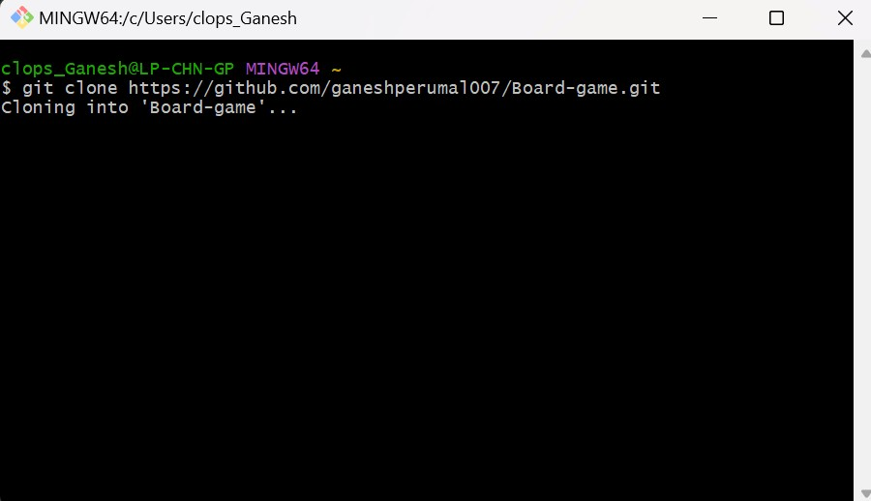
- Replace <repository_URL> with the URL of your private repository.
- Add Your Source Code Files:
  - Navigate into the cloned repository directory. o Paste your source code files or create new ones inside this directory.
- Stage and Commit Changes:
  - Use the git add command to stage the changes:
git add . o Use the git commit command to commit the staged changes along with a meaningful message: git commit -m "Your commit message here"
- Push Changes to the Repository:
  - Use the git push command to push your committed changes to the remote repository git push
  - If it's your first time pushing to this repository, you might need to specify the remote and branch: git push -u origin master
- Replace master with the branch name if you're pushing to a different branch.
- Enter Personal Access Token as Authentication:
  - When prompted for credentials during the push, enter your username (usually your email) and use your personal access token as the password.
By following these steps, you'll be able to create a private Git repository, connect to it using Git Bash, and push your code changes securely using a personal access token for authentication.
PHASE-3 | CICD
Install below Plugins in Jenkins
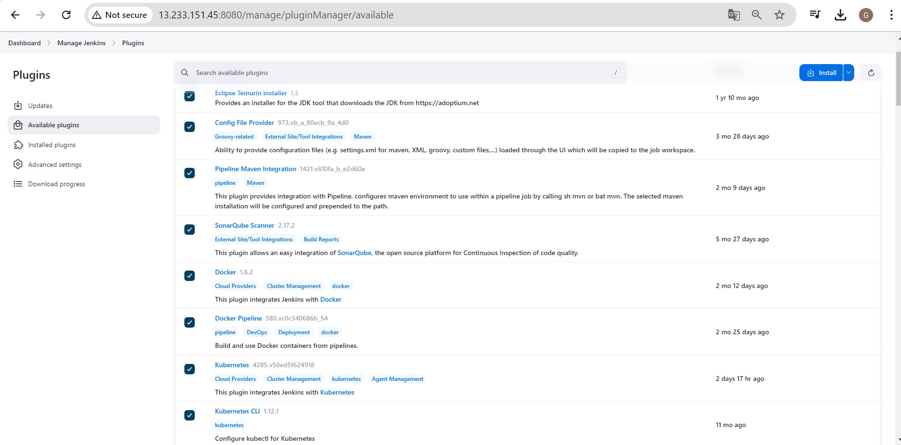
- Eclipse Temurin Installer:
  - This plugin enables Jenkins to automatically install and configure the Eclipse Temurin JDK (formerly known as AdoptOpenJDK).
  - To install, go to Jenkins dashboard -> Manage Jenkins -> Manage Plugins -> Available tab.
  - Search for "Eclipse Temurin Installer" and select it. o Click on the "Install without restart" button.
- Pipeline Maven Integration:
  - This plugin provides Maven support for Jenkins Pipeline.
  - It allows you to use Maven commands directly within your Jenkins Pipeline scripts.
  - To install, follow the same steps as above, but search for "Pipeline Maven Integration" instead.
- Config File Provider:
  - This plugin allows you to define configuration files (e.g., properties, XML,
JSON) centrally in Jenkins.
  - These configurations can then be referenced and used by your Jenkins jobs. o Install it using the same procedure as mentioned earlier.
- SonarQube Scanner:
  - SonarQube is a code quality and security analysis tool.
  - This plugin integrates Jenkins with SonarQube by providing a scanner that analyzes code during builds. o You can install it from the Jenkins plugin manager as described above.
- Kubernetes CLI:
  - This plugin allows Jenkins to interact with Kubernetes clusters using the Kubernetes command-line tool (kubectl).
  - It's useful for tasks like deploying applications to Kubernetes from Jenkins jobs. o Install it through the plugin manager.
- Kubernetes:
  - This plugin integrates Jenkins with Kubernetes by allowing Jenkins agents to run as pods within a Kubernetes cluster.
  - It provides dynamic scaling and resource optimization capabilities for Jenkins builds. o Install it from the Jenkins plugin manager.
- Docker:
  - This plugin allows Jenkins to interact with Docker, enabling Docker builds and integration with Docker registries.
  - You can use it to build Docker images, run Docker containers, and push/pull images from Docker registries. o Install it from the plugin manager.
- Docker Pipeline Step:
  - This plugin extends Jenkins Pipeline with steps to build, publish, and run Docker containers as part of your Pipeline scripts.
  - It provides a convenient way to manage Docker containers directly from
Jenkins Pipelines. o Install it through the plugin manager like the others.
After installing these plugins, you may need to configure them according to your specific environment and requirements. This typically involves setting up credentials, configuring paths, and specifying options in Jenkins global configuration or individual job configurations. Each plugin usually comes with its own set of documentation to guide you through the configuration process.
Configure Above Plugins in Jenkins Pipeline
Configure the tools choose manage jenkins → Tools Choose jdk and fill as given below
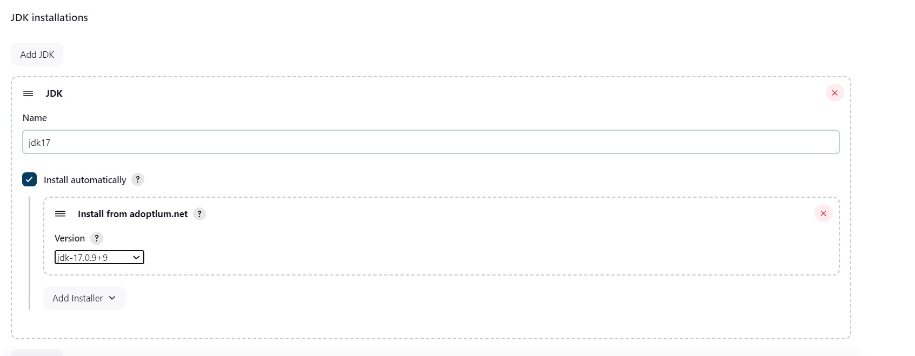
choose sonarqube scanner and configure
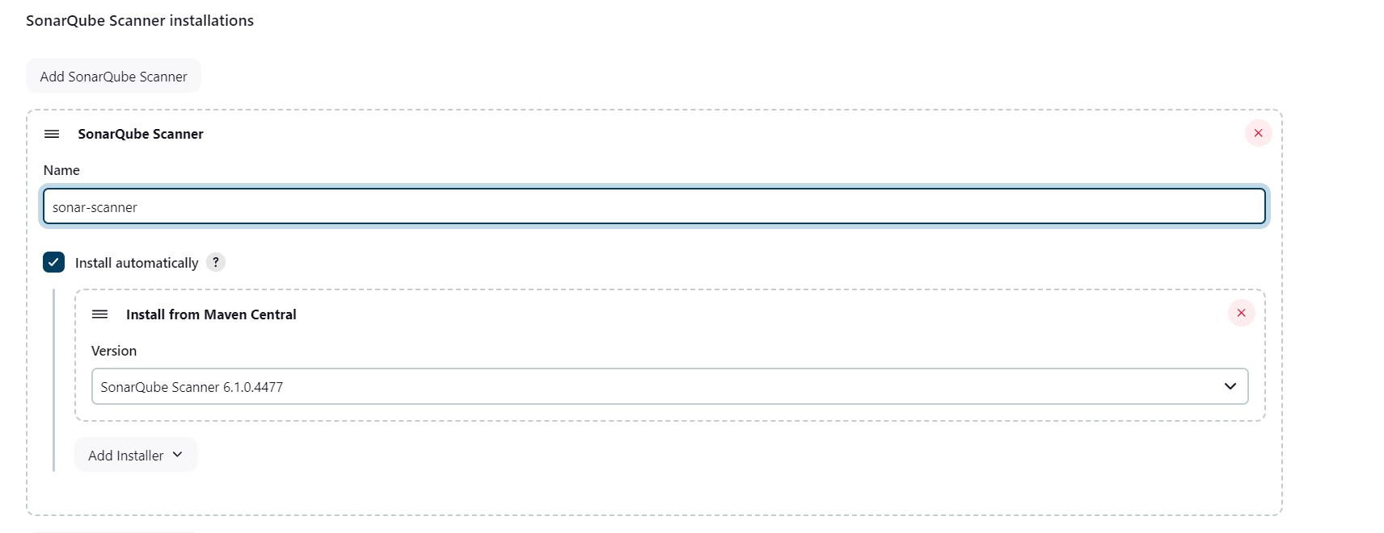
choose maven and Configure
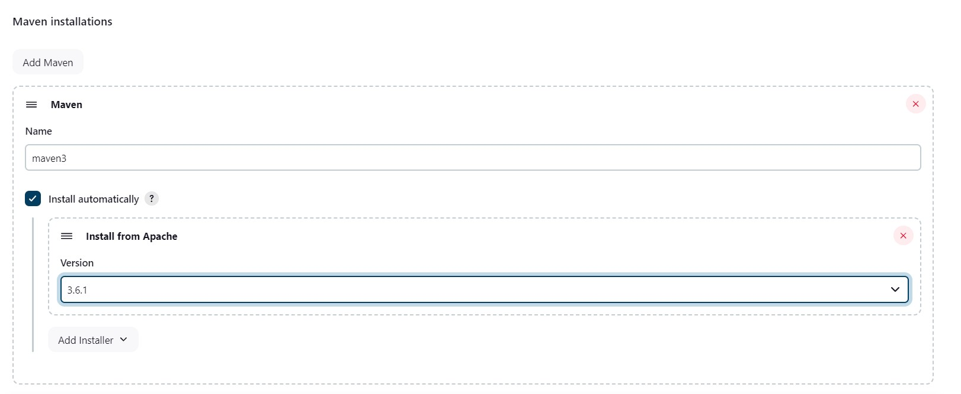
choose Docker and Configure
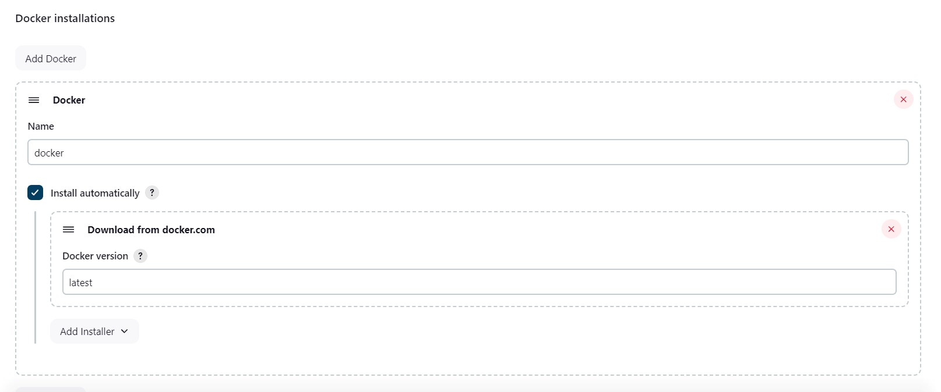
Create the new credentials for sonarqube
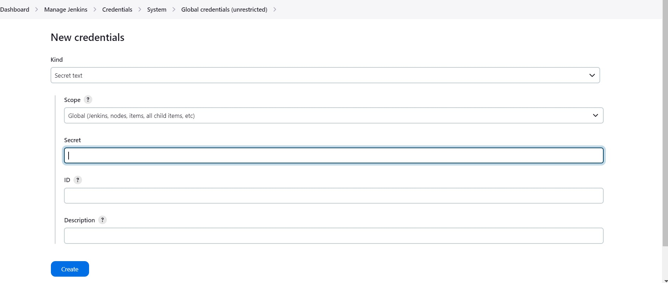
Get the token from sonarcube administration→ security—>generate token
(squ_db0be0fe8e1896ad726617530d37cf233a82993d)
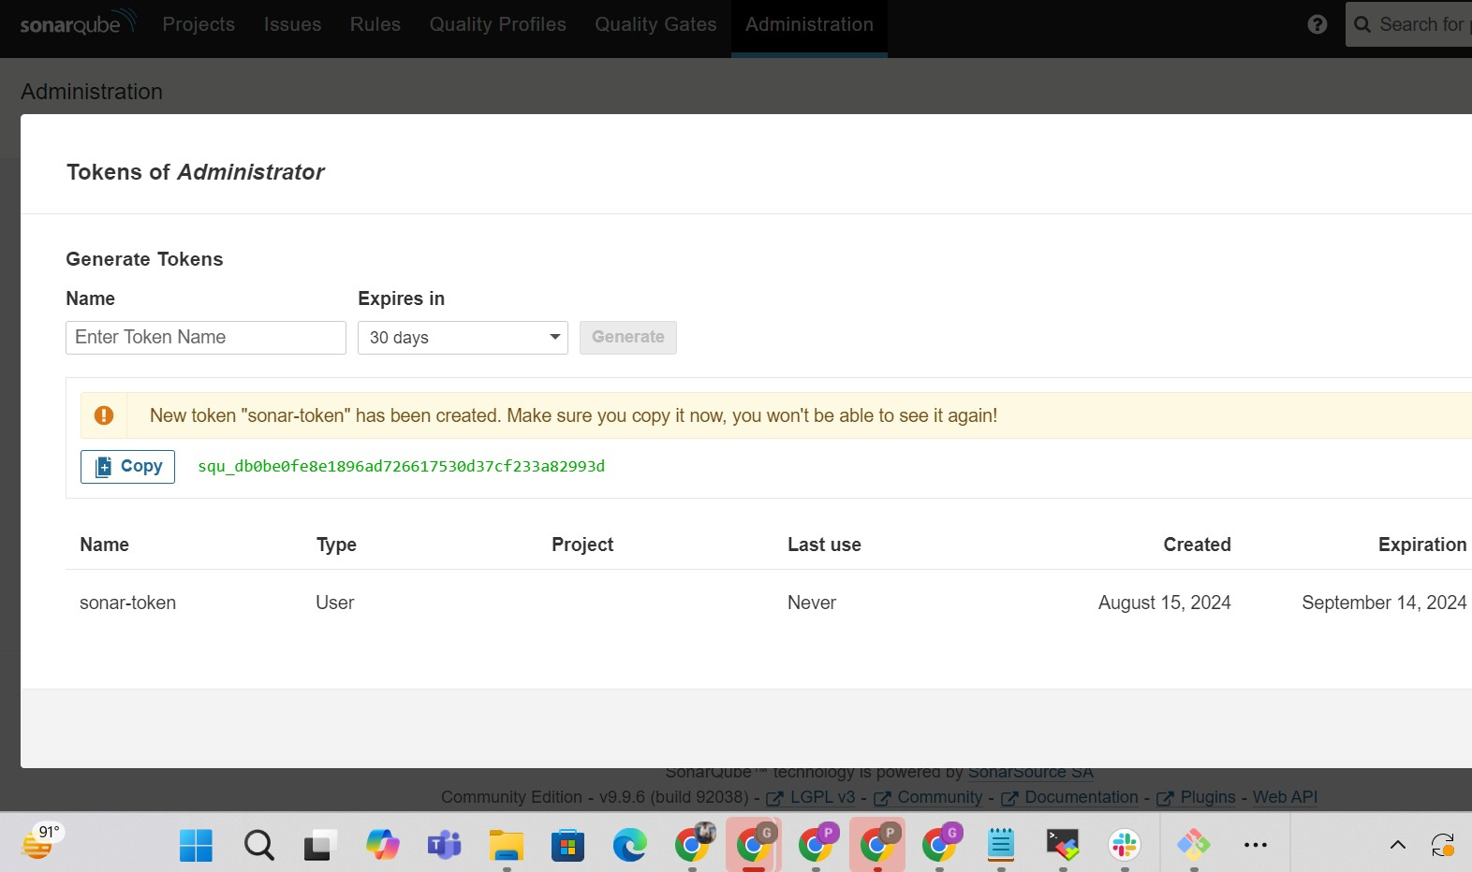
Now need to configure in the sonarqube server Go to manage jenkins >system
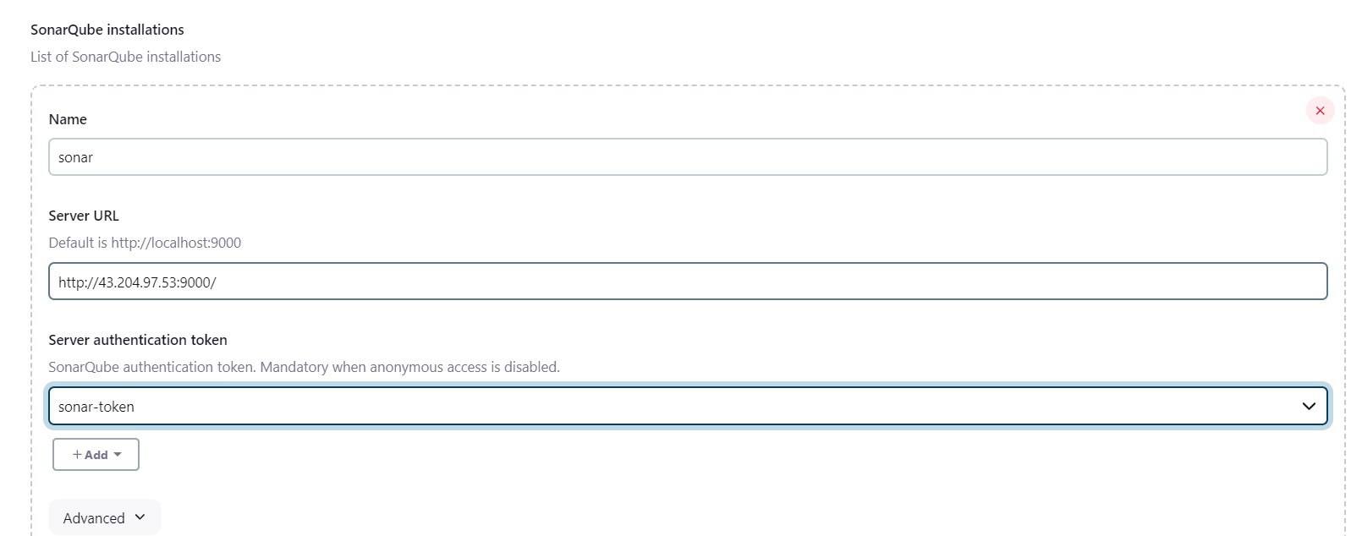
pipeline { agent any
tools {
jdk 'jdk17'
maven 'maven3'
}
environment {
SCANNER_HOME= tool 'sonar-scanner'
}
stages { stage('Git Checkout') {
steps {
git branch: 'main', credentialsId: 'git-cred', url:
'https://github.com/ganeshperumal007/Boardgame.git
'
}
}
stage('Compile') {
steps {
sh "mvn compile"
}
}
stage('Test') {
steps {
sh "mvn test"
}
}
stage('File System Scan') { steps {
sh "trivy fs --format table -o trivy-fs-report.html ."
}
}
stage('SonarQube Analsyis') { steps {
withSonarQubeEnv('sonar') {
sh ''' $SCANNER_HOME/bin/sonar-scanner -
Dsonar.projectName=BoardGame -Dsonar.projectKey=BoardGame \
-Dsonar.java.binaries=. '''
}
}
}
stage('Quality Gate') {
steps {
script {
waitForQualityGate abortPipeline: false, credentialsId: 'sonar-token'
}
}
}
stage('Build') {
steps {
sh "mvn package"
}
}
stage('Publish To Nexus') { steps {
withMaven(globalMavenSettingsConfig: 'global-settings', jdk: 'jdk17',
maven: 'maven3', mavenSettingsConfig: '', traceability: true) { sh "mvn deploy"
}
}
}
stage('Build & Tag Docker Image') { steps {
script {
withDockerRegistry(credentialsId: 'docker-cred', toolName: 'docker') { sh "docker build -t ganeshperumal007/boardshack:latest ."
}
}
}
}
stage('Docker Image Scan') { steps {
sh "trivy image --format table -o trivy-image-report.html
ganeshperumal007/boardshack:latest "
}
}
stage('Push Docker Image') { steps {
script {
withDockerRegistry(credentialsId: 'docker-cred', toolName: 'docker') { sh "docker push ganeshperumal007/boardshack:latest"
}
}
}
}
stage('Deploy To Kubernetes') { steps {
withKubeConfig(caCertificate: '', clusterName: 'kubernetes', contextName: '', credentialsId: 'k8-cred', namespace: 'webapps', restrictKubeConfigAccess: false, serverUrl: 'https://172.31.8.146:6443') { sh "kubectl apply -f deployment-service.yaml"
}
}
}
stage('Verify the Deployment') { steps {
withKubeConfig(caCertificate: '', clusterName: 'kubernetes', contextName: '', credentialsId: 'k8-cred', namespace: 'webapps', restrictKubeConfigAccess: false, serverUrl: 'https://172.31.8.146:6443') { sh "kubectl get pods -n webapps"
sh "kubectl get svc -n webapps"
}
}
}
}
post { always { script {
def jobName = env.JOB_NAME def buildNumber = env.BUILD_NUMBER def pipelineStatus = currentBuild.result ?: 'UNKNOWN'
def bannerColor = pipelineStatus.toUpperCase() == 'SUCCESS' ? 'green' : 'red'
def body = """
<html>
<body>
<div style="border: 4px solid ${bannerColor}; padding:
10px;"> <h2>${jobName} - Build
${buildNumber}</h2>
<div style="background-color:
10px;"> ${bannerColor}; padding:
<h3 style="color: white;">Pipeline Status:
${pipelineStatus.toUpperCase()}</h3>
</div>
<p>Check the <a href="${BUILD_URL}">console
output</a>.</p> </div>
</body>
</html> """
emailext (
subject: "${jobName} - Build ${buildNumber} -
${pipelineStatus.toUpperCase()}", body: body, to:
'ganeshperumal882000@gmail.co m', from: 'jenkins@example.com', replyTo: 'jenkins@example.com', mimeType: 'text/html', attachmentsPattern: 'trivy-image-report.html'
)
}
}
}
}

OUTPUT
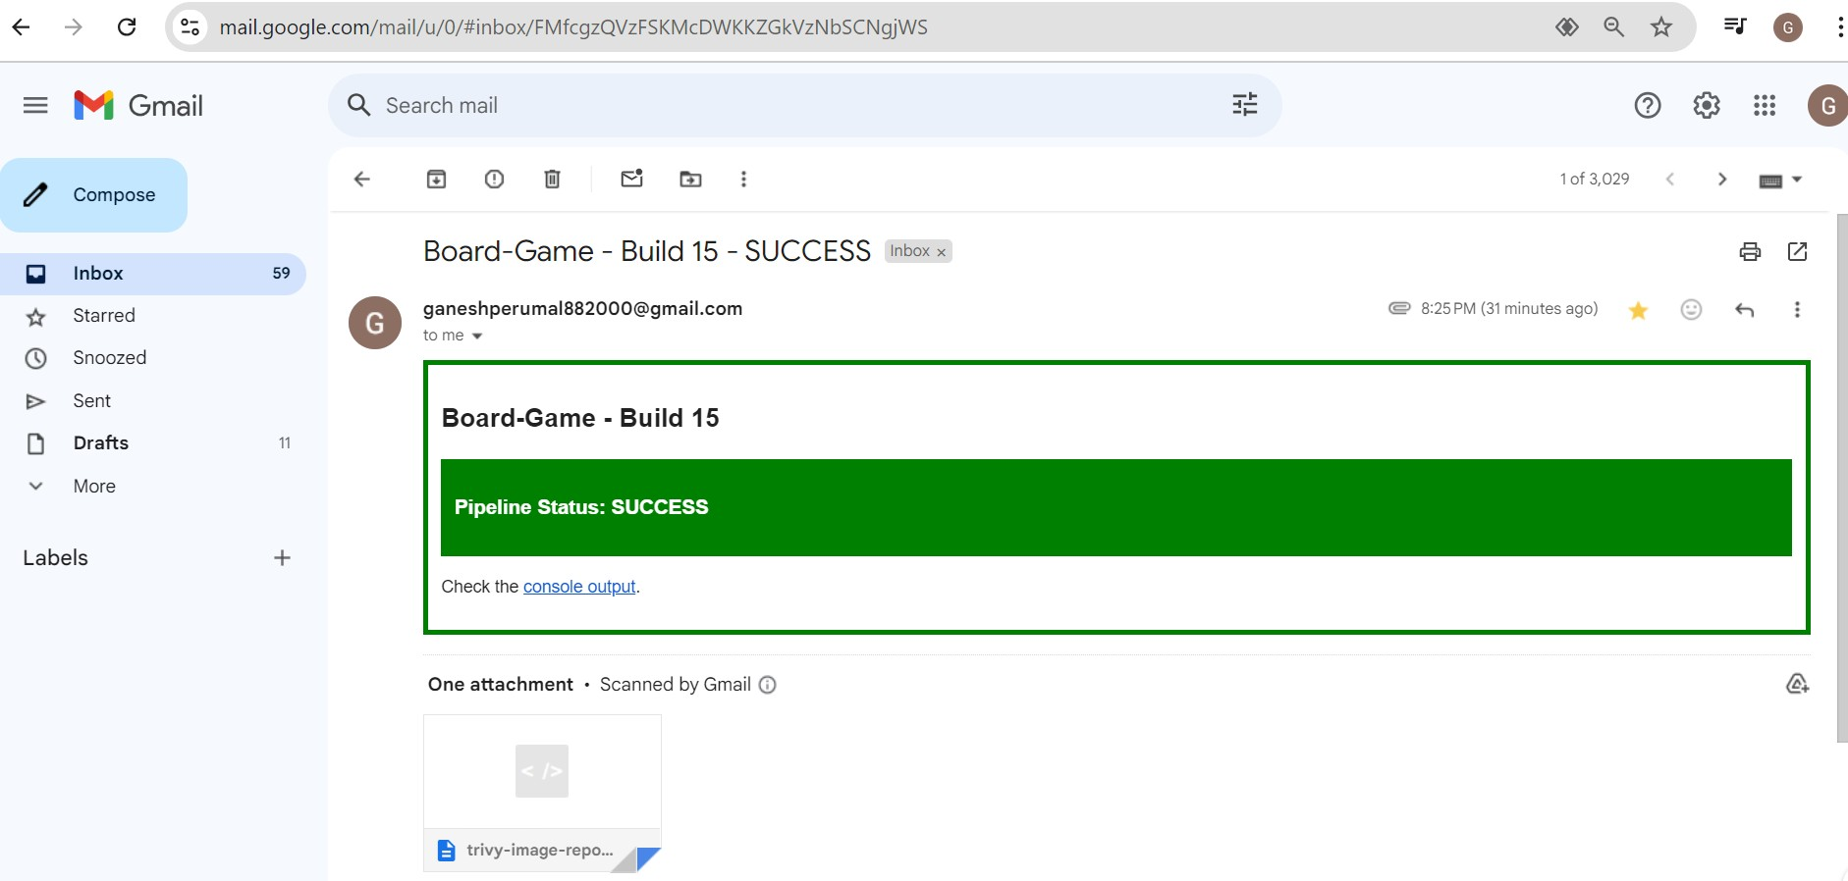
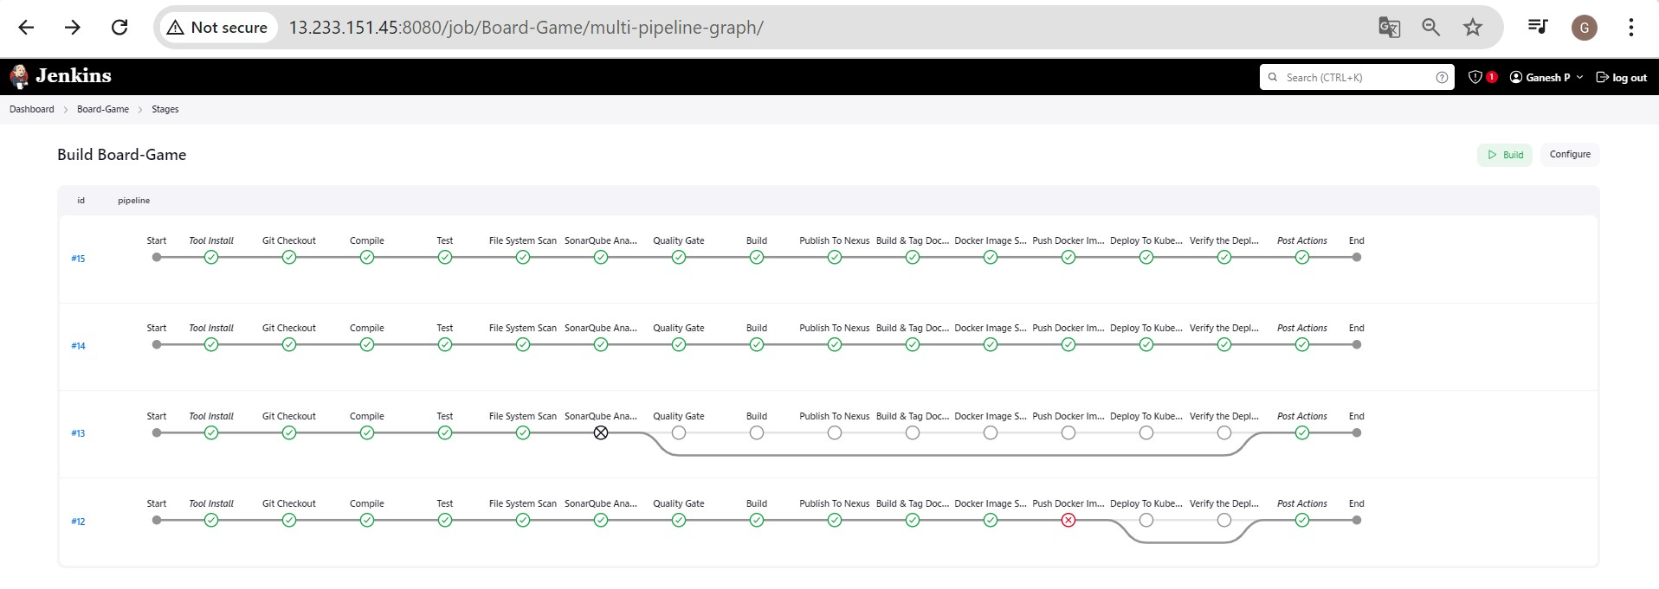

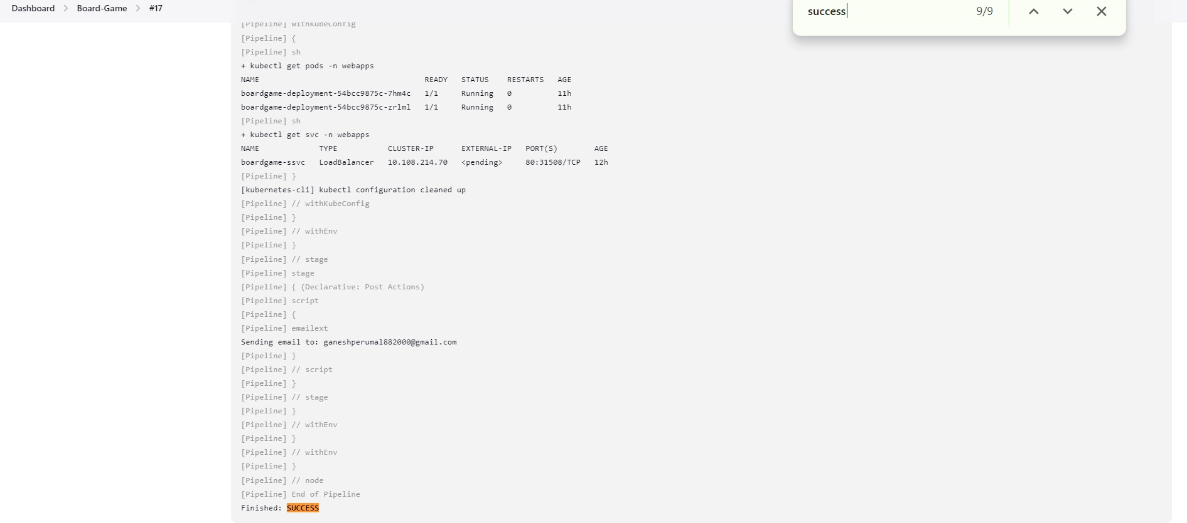
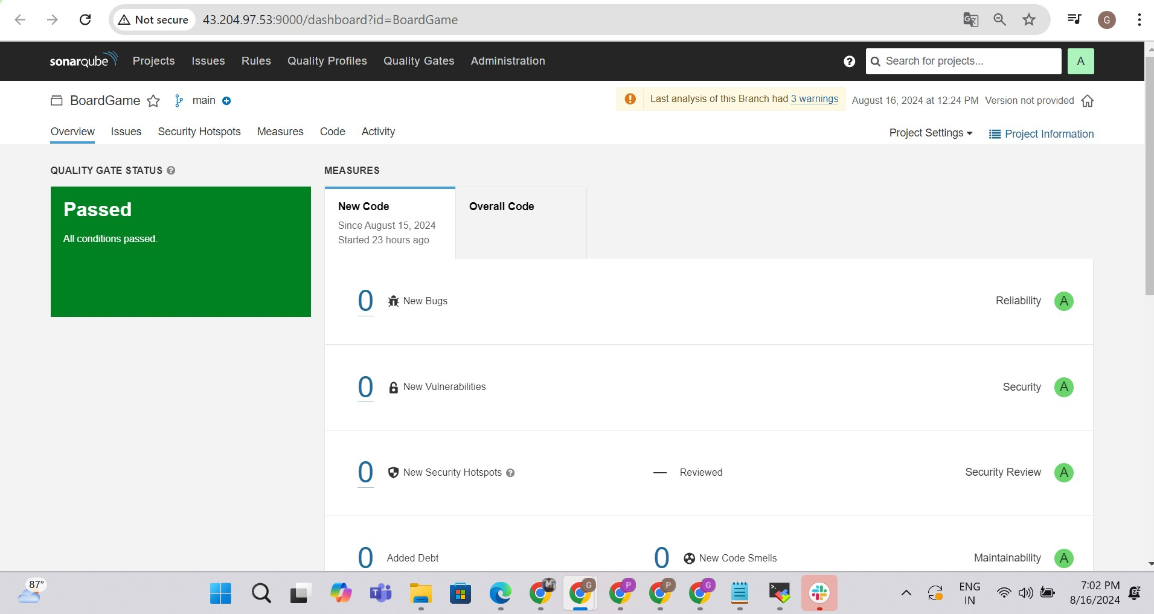

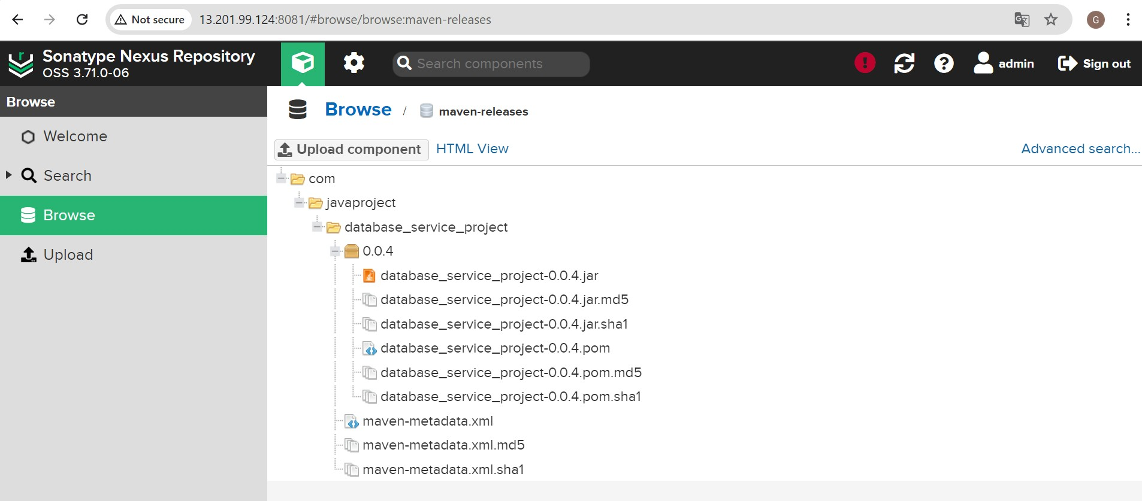
Now we can able to access the see our application is running in slave machine 1&2
Check the ip address of both slave 1 & 2 http://yourip:31508/
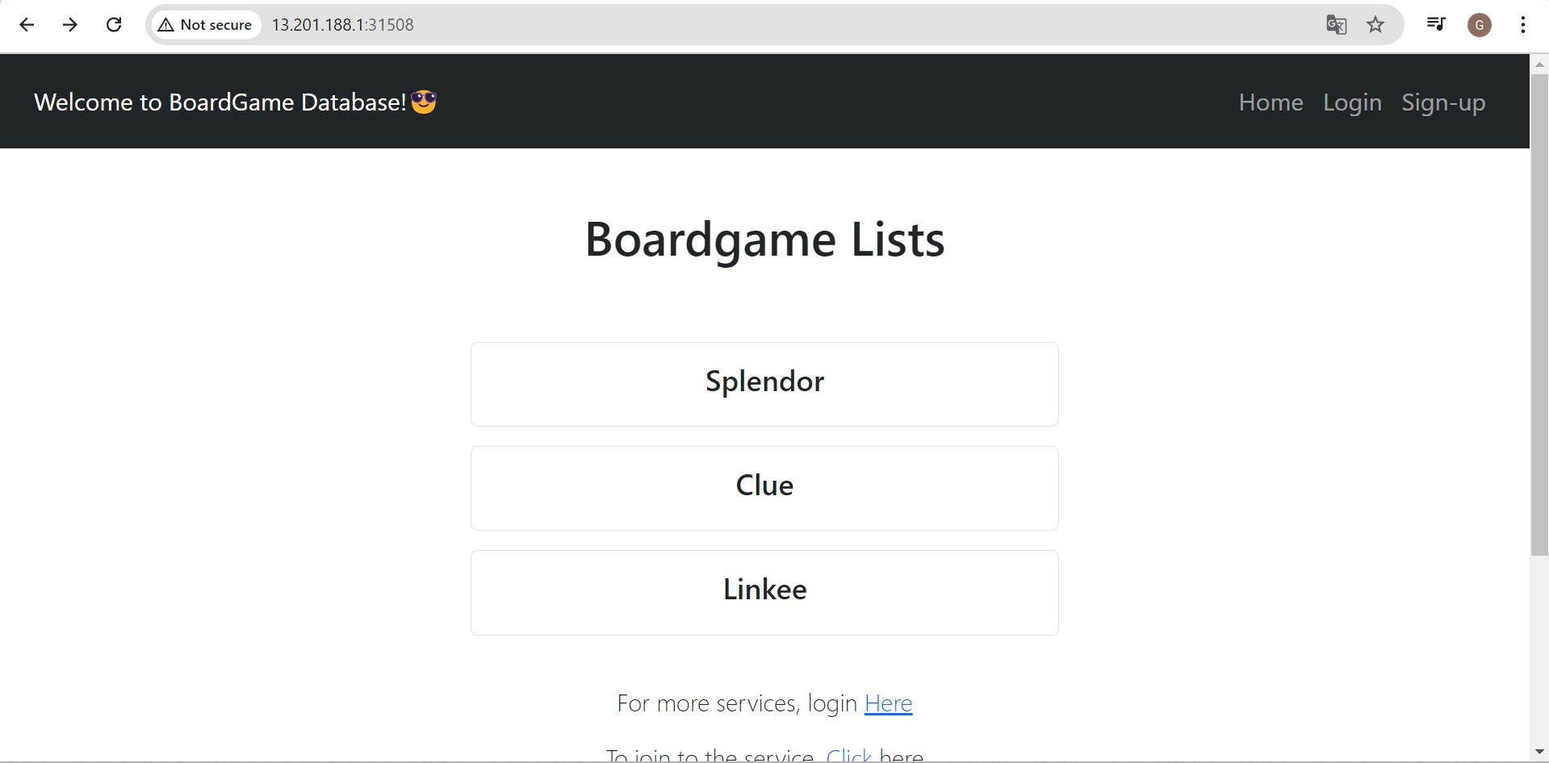
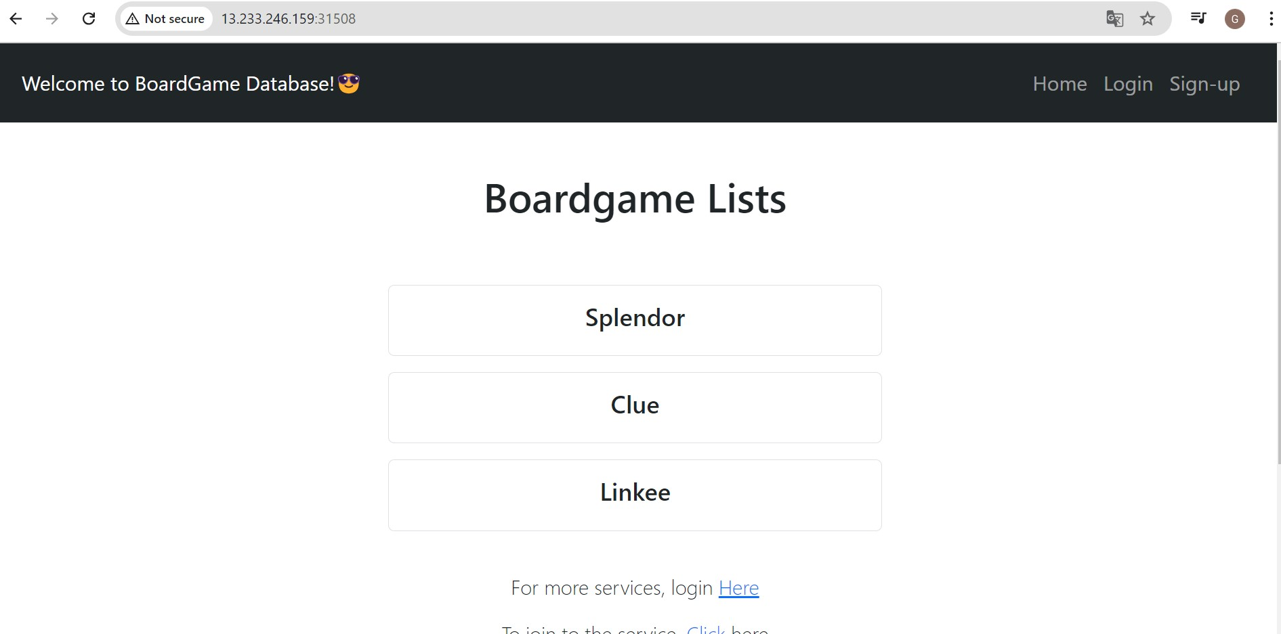
If You face issue while rebuilding the artifacts is not uploaded , Allow re-deploy in the settings choose settings —>administration —> repositories —> maven-releases there you can enable the re-deploy option as shown below in the picture
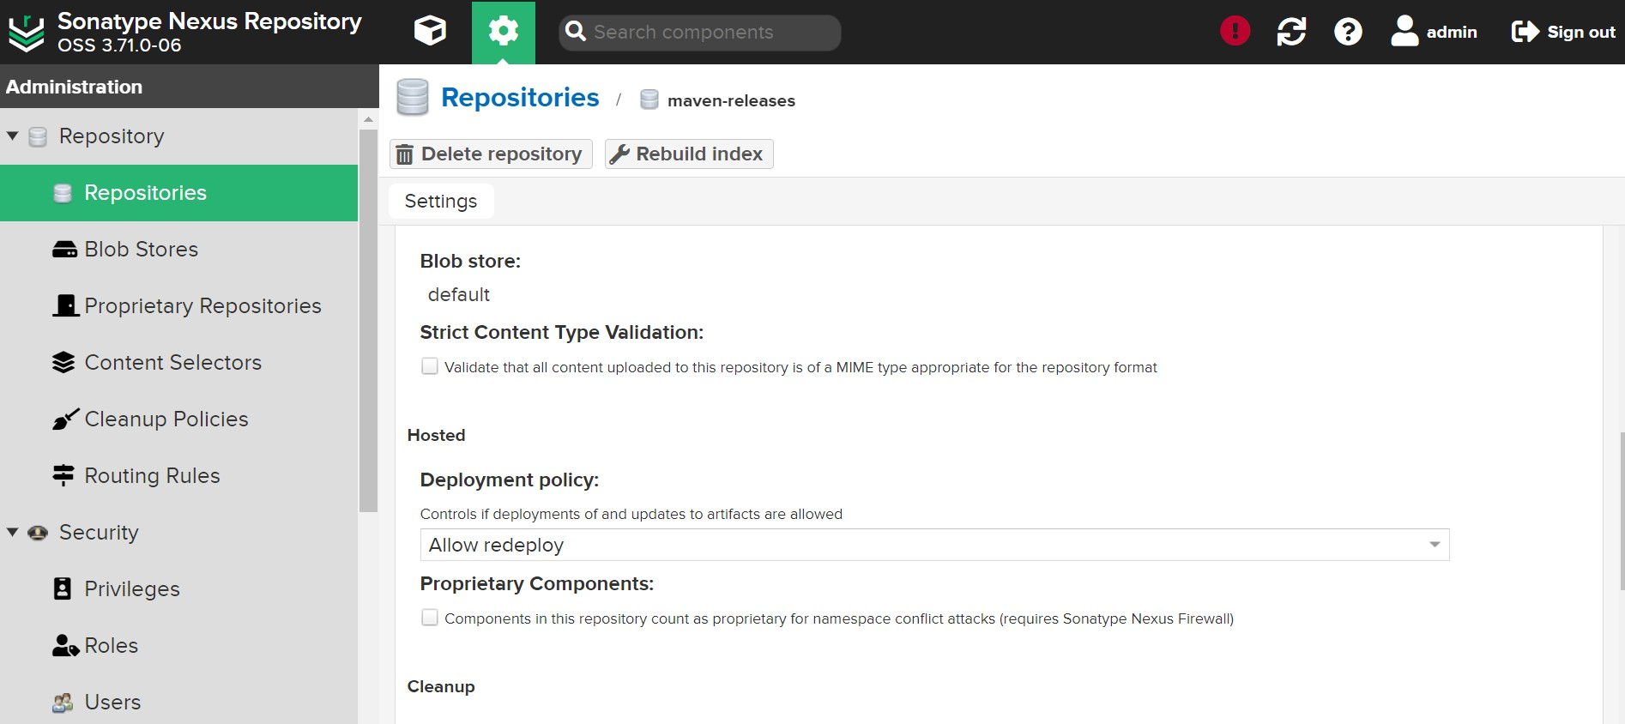

PHASE-4 | Monitoring
Launch an EC2 instances with the t2.medium and start setup installation prometheus and Grafana
Before Starting Installation Update the package sudo apt update

1.Links to download Prometheus, Node_Exporter & black Box exporter https://prometheus.io/download/
Download the latest prometheus
Copy the link from the above official document website and download in your local machine
wget
https://github.com/prometheus/prometheus/releases/download/v2.54.0/prometheu s-2.54.0.linux-amd64.tar.gz
Extract the downloaded archive
tar -xvf prometheus-2.54.0.linux-amd64.tar.gz cd prometheus-2.54.0.linux-amd64/
Now give ls we can able to see the executable file in the name of prometheus
,To start prometheus run the executable script in the name prometheus ./prometheus.sh &
http://<your_server_IP>:9090/
Now we can able to access the prometheus ,.
2.Links to download

Grafana https://grafana.com/grafana/download
Refer the official documentation and install the latest version
sudo apt-get install -y adduser libfontconfig1 musl
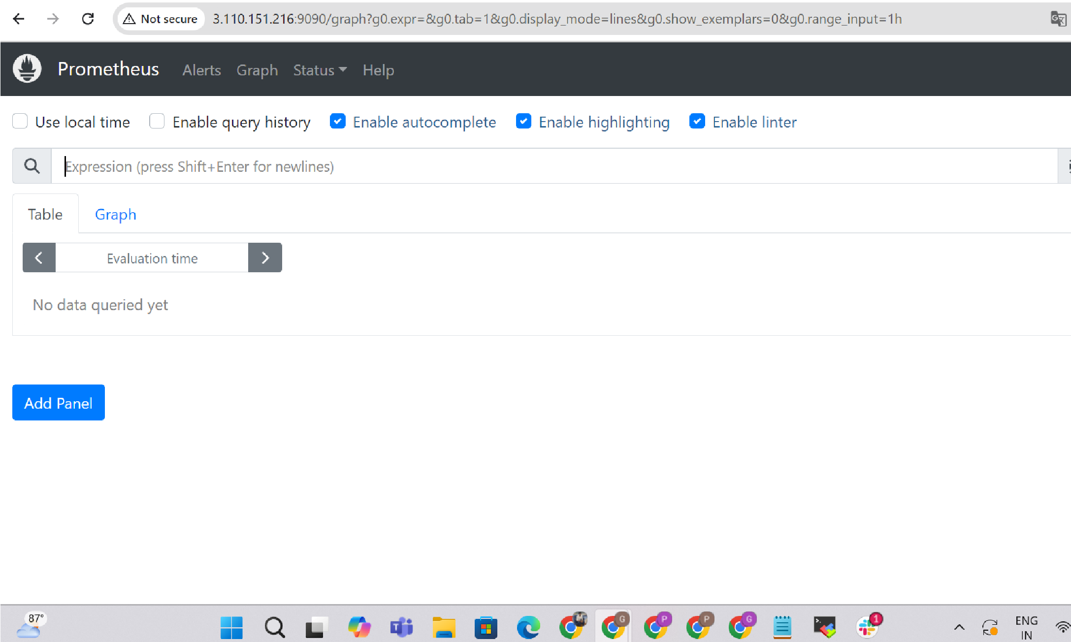
wgethttps://dl.grafana.com/enterprise/release/grafana-enterprise_11.1.4_amd64.deb sudo dpkg -i grafana-enterprise_11.1.4_amd64.deb

### You can start grafana-server by executing
sudo /bin/systemctl start grafana-server
Grafana is running now, and we can connect to it at http://your.server.ip:3000 The default user & password is admin / admin.
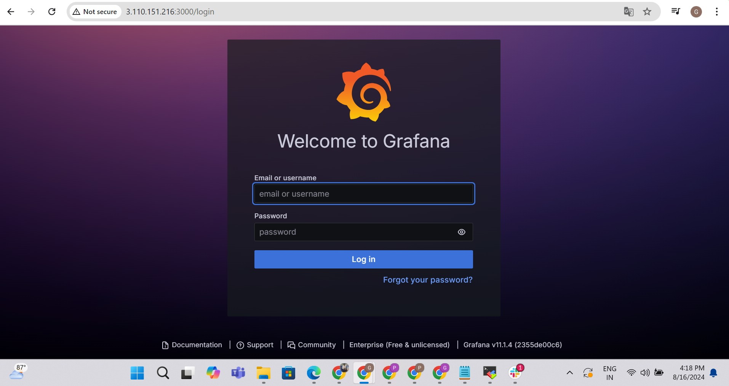
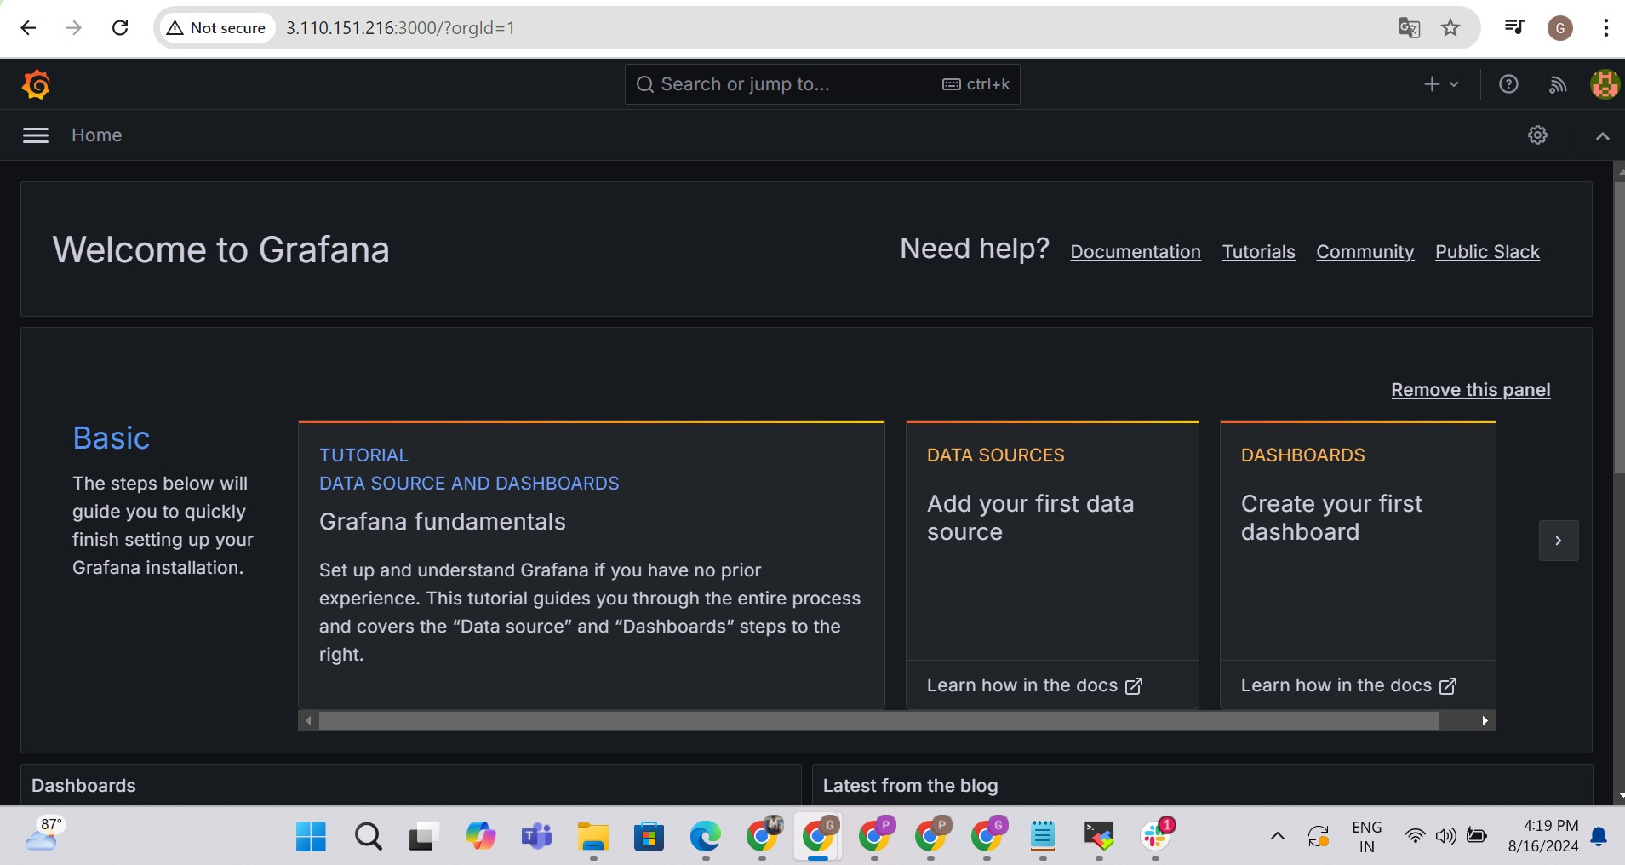

3.https://github.com/prometheus/blackbox_exporter

Download blackbox exporter from the o cial website of prometheus,
wget https://github.com/prometheus/blackbox_exporter/releases/download/v0.25.0/blackbox_exporter-0.2 5.0.linux-amd64.tar.gz
Now Extract the tar file of blackbox exporter
tar -xvf blackbox_exporter-0.25.0.linux-amd64.tar.gz

To start the black box exporter
cd blackbox_exporter-0.25.0.linux-amd64/
Now give ls we can able to see the executable file in the name of blackbox ,To start blackbox run the executable script in the name blackbox
./blackbox_exporter &
http://<your_server_IP>:9115/
Now we can able to access the prometheus ,.
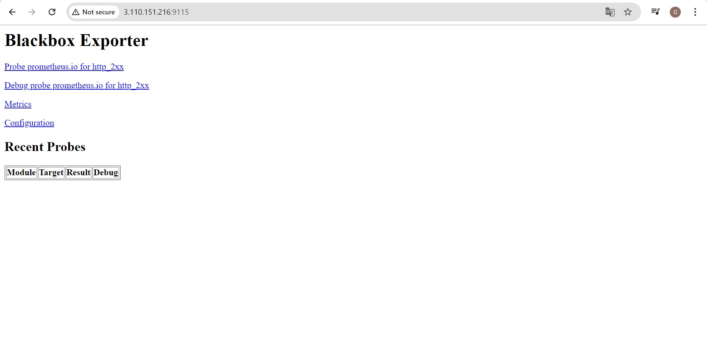
PrometheusyamlConfiguration
cd prometheus-2.54.0.linux-amd64/ ls vi prometheus.yml
# Load rules once and periodically evaluate them according to the global
'evaluation_interval'. rule_files:
# - "first_rules.yml"
# - "second_rules.yml"
# A scrape configuration containing exactly one endpoint to scrape:
# Here it's Prometheus itself.
scrape_configs:
# The job name is added as a label `job=<job_name>` to any timeseries scraped from this
config.
- job_name: "prometheus"
# metrics_path defaults to '/metrics' # scheme defaults to 'http'.
static_configs:
- targets: ["localhost:9090"]
- job_name: 'blackbox' metrics_path: /probe params:
module: [http_2xx] # Look for a HTTP 200 response.
static_configs:
- targets:
- http://prometheus.io # Target to probe with http
- http://13.201.188.1:31508/ # Target to probe with http on port 31508 our application.
relabel_configs:
- source_labels: [__address__] target_label: __param_target
- source_labels: [__param_target] target_label: instance
- target_label: __address__
replacement: 3.110.151.216:9115 # The blackbox exporter's real hostname:127.0.0.1:
Now need to restart the prometheus
pgrep prometheus
it will shows the id kill the id kill 1992
Then restart
./prometheus &
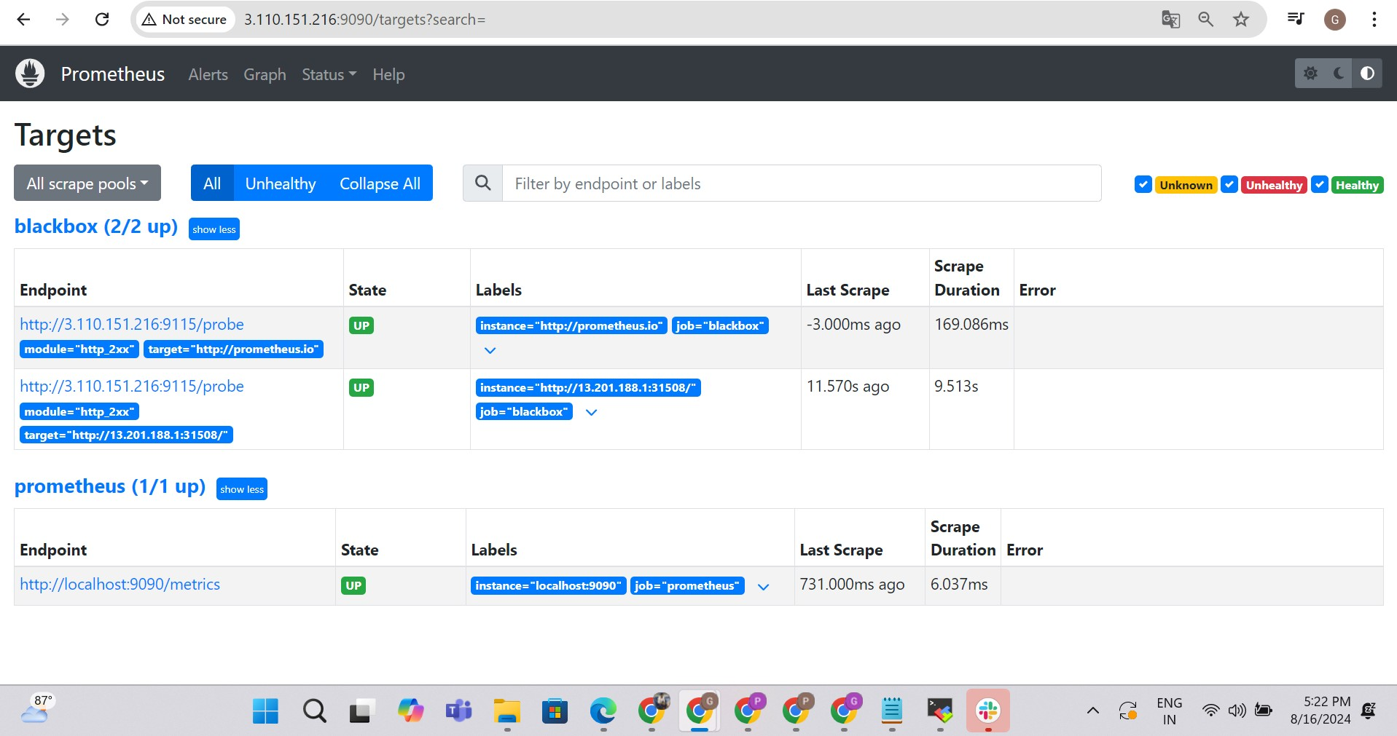
NOW We Need to add prometheus as our datasource in Grafana
Then Import dashboard give ID 7587 to create black box exporter
dashboard
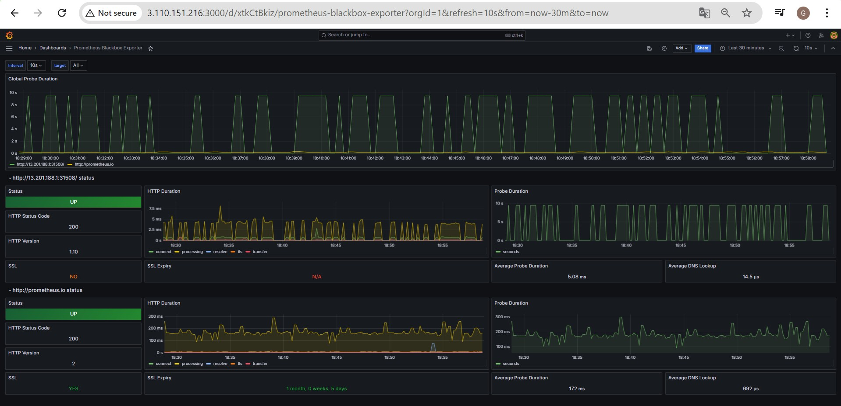
let us monitor the jenkins machine metrics by node exporter install prometheus metrics plugins in jenkins
let us download the node exporter in jenkins machine
wget https://github.com/prometheus/node_exporter/releases/download/v1.8.2/node_expor ter-1.8.2.linux-amd64.tar.gz Now extract the file
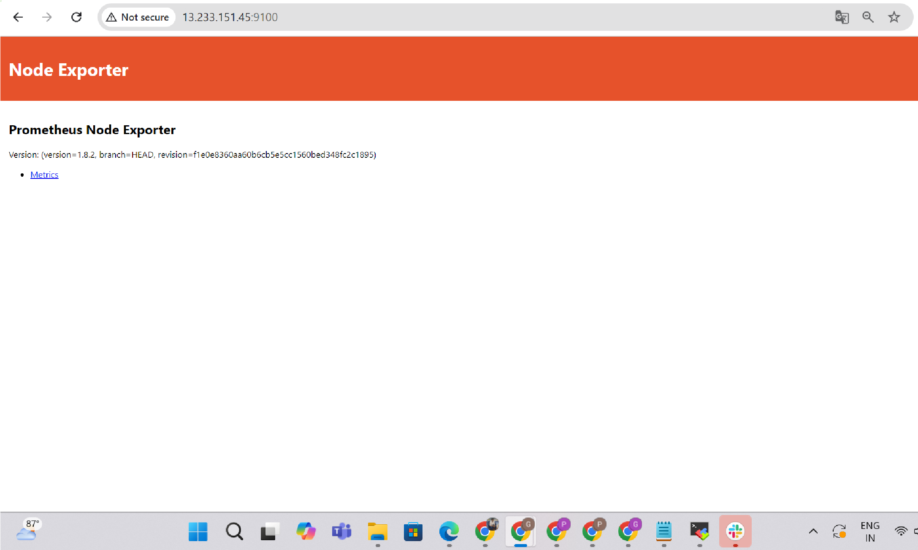
tar -xvf node_exporter-1.8.2.linux-amd64.tar.gz
Now run the nodeexporter script
cd node_exporter-1.8.2.linux-amd64/ ls
./node_exporter &
Now nodeExporter can be accessible through the browser
http://<your_server_IP>:9100
Make sure the below one was configured in manage jenkins→system
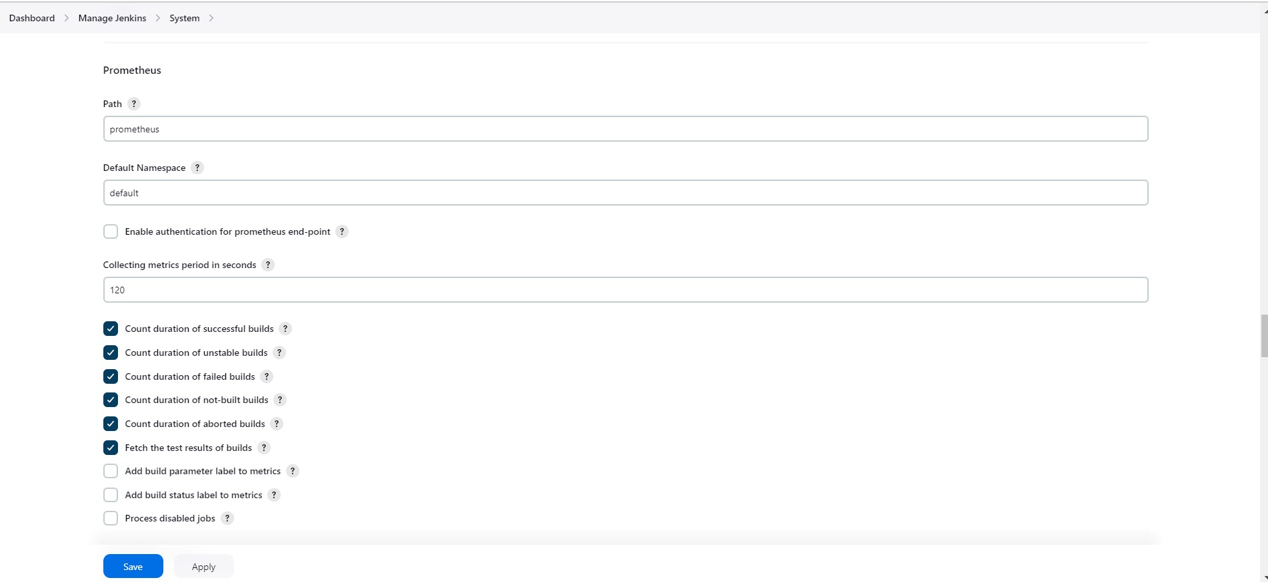
now need to edit the yaml file of prometheus
vi prometheus.yaml
#update the yaml file
- job_name: 'node_exporter' static_configs:
- targets: ['13.233.151.45:9100']
- job_name: 'Jenkins' metrics_path: '/prometheus' static_configs:
- targets: ['13.233.151.45:8080']
After update the yaml file make sure restart the prometheus
pgrep prometheus kill id
./prometheus &
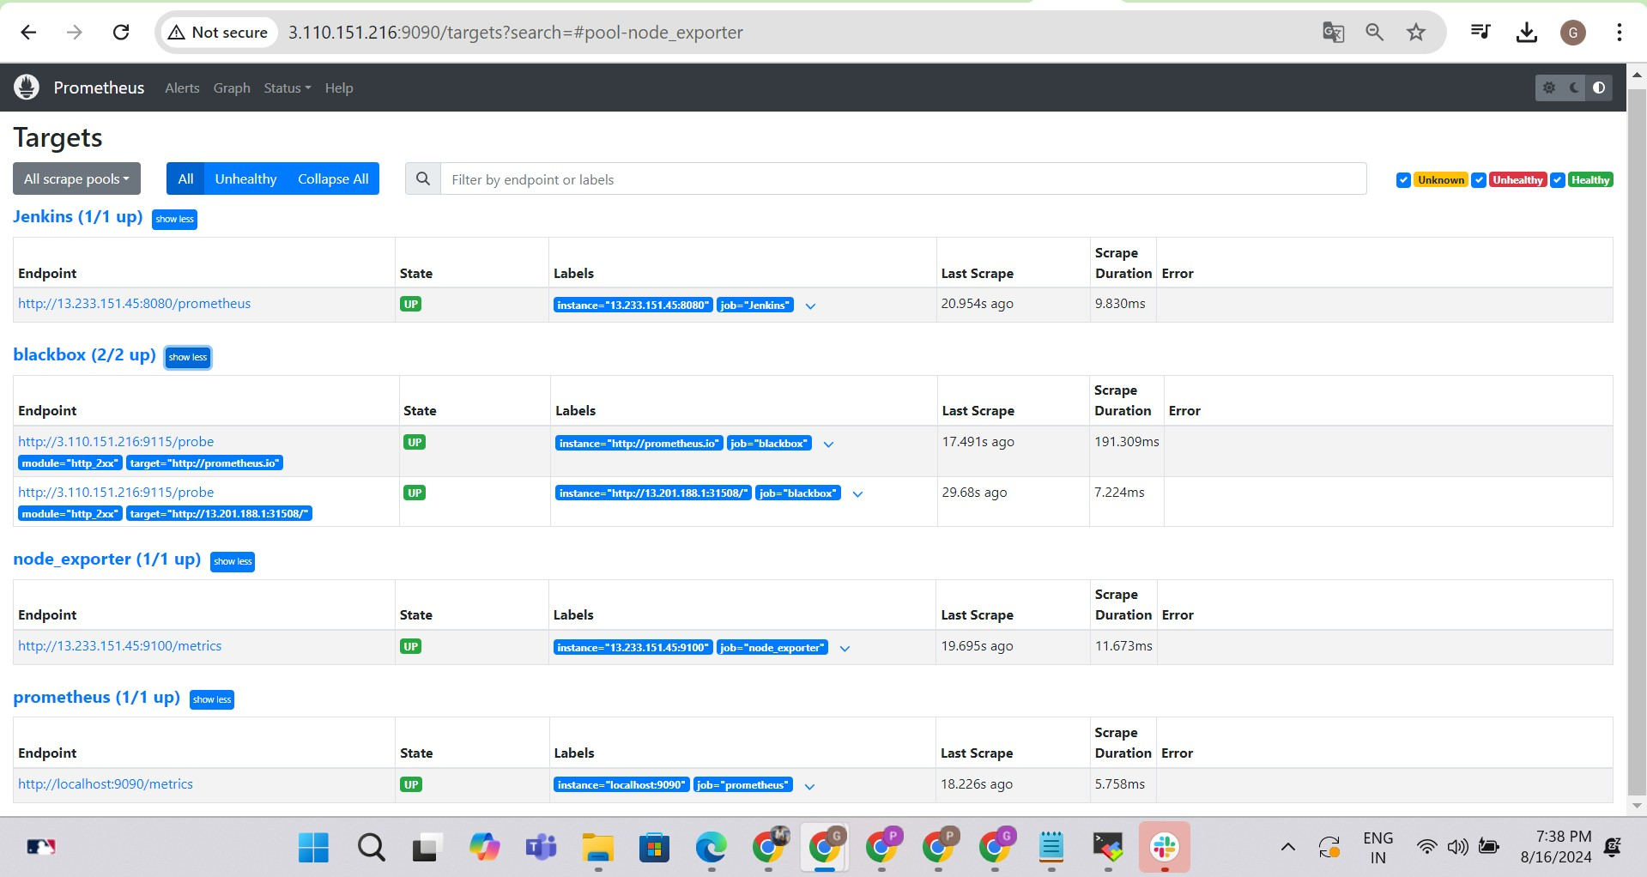
Now in Grafana Create another dashboard for node exporter
import dashboard id - 1860
